Tissue necrosis prevention during shoot multiplication of coconut

Hannes Wilms¹*, Dries De Bièvre¹, Evelien Rosiers¹, Rony Swennen^{1,2}, Juhee Rhee³, Bart Panis^{1,4}

1 KU Leuven, Dept. Biosystems, Belgium 2 International Institute of Tropical Agriculture (IITA), Plot 15B Naguru East Road, Upper Naguru, Box 7878, Kampala, Uganda 3 National Agrobiodiversity Center, RDA, Jeonju, Korea 4 Bioversity International, Belgian Office *(Hannes.wilms@kuleuven.be)

Abstract
The demand for coconut products, such as coconut-oil, -water and -milk, is rising worldwide. However, coconut production is currently not able to keep up with the demand due to ageing plantations, pests and diseases. Large quantities of highly producing, disease resistant and drought tolerant coconut plantlets are therefore urgently needed. We developed an innovative clonal micro propagation method, that enables mass production of desired varieties. With current in vitro methods and during the propagation phase, tissue browning or necrosis of parts of the proliferating material occurs routinely. We demonstrate that the addition of 1g L-1 activated charcoal (AC) prevented shoot propagation. Therefore we opted for components that do not interfere with the plant growth regulators present in the medium, such as ascorbic acid, which prevents oxidation and silver thiosulfate, an ethylene inhibitor. While different concentrations of ascorbic acid were shown not to affect tissue necrosis, increasing concentrations of silver thiosulfate prevented more tissue necrosis. Tissue necrosis mostly started 4-5 weeks after subculture, suggesting that shorter subculture cycles could also help mitigate this problem.

Keywords: Activated Charcoal, Ascorbic acid, Cocos, Light sensitivity, Micropropagation, Photooxidation, Silver Thiosulfate

INTRODUCTION
The coconut palm played a significant role in history, as this palm provided many communities in the Pacific and Indian ocean (Gunn et al., 2011), with different goods such as food, timber and oil (Punchihewa and Arancon, 1999). This versatility made the palm popular around the equator (Gunn et al., 2011). In 2019, the global coconut palm production reached 62.5 M tons (FAO, 2021), estimated at $ 11.5 billion (Research and Markets, 2019). These numbers are expected to further increase, with the beverage industry creating new plantations while promoting coconut water as a healthy soda alternative (Research and Markets, 2019).
However, the coconut industry faces some crises. Firstly, deadly diseases such as Lethal yellowing (Eziashi and Omamor, 2010) and Coconut cadang-cadang (Vadamalai et al., 2009) are infecting plantations and due to globalization these diseases spread more easily (Bandyopadhyay and Frederiksen, 1999). Secondly, due to climate change, extreme weather conditions, such as extreme heath or hurricanes are likely to become more common (Akhtar, 2019), hindering or stopping plant growth. Thirdly, most of current plantations are past their economic lifespan (Karun, 2017; Bene et al., 2009) and are in dire need of replanting to remain economically viable. These crises combined with the lack of planting material for new plantations, causes two challenges: the danger of losing unique material and the lack of new quality planting material. These problems could be solved by providing a safe conservation and mass propagation method respectively.
Multiple conservation methods exist such as, seed storage, field banks and in vitro collections. However not all methods solve previously mentioned problems; field banks are subjected to pests and diseases and due to the recalcitrant nature of the coconut (Engelmann et al., 2011), seed conservation is not possible. Hence in vitro culture and cryopreservation are the remaining options to provide a long term solution.
There have been multiple, successful, attempts in developing a cryopreservation protocol for coconut (Kim et al., 2019; Rajesh et al., 2019; Sisunandar et al., 2010, 2014; Welewanni and Bandupriya, 2017). However, these methods rely on zygotic embryo’s or plumules derived from them and do not take the prospect of clonally micropropagated plantlets/shoots into account. Bioversity International, RDA and KU Leuven therefore developed a cryopreservation protocol based on rooted in vitro plants (Wilms et al., 2019) as well as on multiplying shoot clusters that could provide more material for storage while also tackling the lack of planting material.
This effort resulted in the development of a micropropagation protocol via axillary shoot propagation, which was the first of its kind in coconut tissue culture (Wilms et al., accepted 2021). This method contrasts with earlier propagation methods such as somatic embryogenesis (Caren et al., 2019; Mu, 2020; Sáenz et al., 2010) as the latter is generally linked to a putative higher rate of somaclonal variation (Rival et al., 2013). The proliferating material that was obtained with the novel protocol shows a monthly increase of 50-100%, however, during the proliferation and regeneration some of the material is lost due to browning and necrosis.
This study aims to reduce the loss of material due to tissue necrosis in the coconut micropropagation protocol. We did this by pinpointing two steps in the process where some browning occurs and applied different tissue necrosis preventative measures.

MATERIALS AND METHODS

Plant material
The plant material originated from zygotic coconut embryos that were excised at the PCA-Zamboanga Research Center in the Philippines, from 10- to 11-month-old nuts of the ‘Malayan Yellow Dwarf’ (MYD) cultivar following the protocol described by Engelmann et al., (2011). The embryos were then shipped by air courier to Belgium in cryovials containing semi-solid Y3 medium (Eeuwens, 1976) devoid of sugar and activated charcoal (AC). There they were sterilized, germinated and grown following the protocols described by Wilms et al., (2019). The plantlets that were used for the initiation of proliferation were at least 4 months old and were cut vertically in half and transferred to a solid Y3 medium containing 1µM thidiazuron (TDZ). When the plantlets started to show proliferating meristem clusters, these were excised and subcultured every month in the dark on semi-solid Y3 medium containing 1µM TDZ.

Medium preparation
All media contained demi water, Y3 salts and vitamins (Eeuwens, 1976; Rillo et al., 2002), and were mixed together with the components mentioned in the separate experiments. The pH was set to 6.12 whereafter they were dispensed in their recipient and autoclaved, unless otherwise mentioned.

Effect of AC on the initiation of micropropagation
Seventy plantlets were initiated following the earlier mentioned induction protocol. After the cut was made, half of the plantlets were transferred to solid Y3 medium containing 40 g L-1 sucrose, 2g L-1 gelrite, and 1µM TDZ. The other half of the plantlets was transferred to solid Y3 medium containing 40 g L-1 sucrose, 2g L-1 gelrite, 1µM TDZ and 1 g L-1 AC. Afterwards the plants were transferred to a 24-26°C growth chamber with a 16h/8h light/dark cycle The plants were monitored for 45 days after which the number of proliferating meristems in each group was counted. These results where then compared using a contingency analysis with an alpha level of 0.05 in the statistical program JMP.
Effect of AC on multiplication of proliferating meristems
One hundred and twenty clumps of proliferating meristems without browning and with a volume of 1 cm³ were divided equally over 15 media with the cut side facing down in the medium. The media are presented in table 1. After the start of the experiment, the proliferating meristems were placed in the growth chamber at 24-26 °C in the dark. Over the course of 3 weeks growth (diameter in mm), browning and regeneration (outgrowth) were screened. Browning and regeneration were both measured for each cluster of proliferating meristems using a ordinal rating system. For browning: no browning (score 1), ≤20% (score 2), ≤50% (score 3), ≤75% (score 4) to 100% browning (score 5). For Regeneration: no visible change (score 1), some small leaves forming (<1mm) (score 2), some small leaves forming (>1mm; <3mm) (score 3), many small leaves forming on the whole proliferating structure (score 4) and multiple leaves forming (>3mm) (score 5). These results where then compared using a contingency analysis with an alpha level of 0.05 in the statistical program JMP

Table 1: Experimental set up, proliferating meristems were put on 15 different media containing Y3 medium with 40 g L-1 sucrose , 2g L-1 gelrite, and a mixture of activated charcoal (AC) and thidiazuron (TDZ)
 |  | TDZ (µM)
 |  | 1 | 10 | 100
AC ( g L-1) | 0 | Treatment 1 | Treatment 2 | Treatment 3
AC ( g L-1) | 0.0005 | Treatment 4 | Treatment 5 | Treatment 6
AC ( g L-1) | 0.005 | Treatment 7 | Treatment 8 | Treatment 9
AC ( g L-1) | 0.05 | Treatment 10 | Treatment 11 | Treatment 12
AC ( g L-1) | 0.5 | Treatment 13 | Treatment 14 | Treatment 15

Effect of Silver thiosulfate (STS) and ascorbic acid on proliferating meristems
Ninety six clumps of proliferating meristems without browning where equally divided over 8 different medium treatments similarly to the previous experiment. The media consisted of Y3 medium containing 40 g L-1 sucrose , 2g L-1 gelrite, 1µM TDZ and (0; 1; 10 or 100 µM STS) or (0; 10; 100 or 1000 mg L-1 ascorbic acid). During the medium preparation the ascorbic acid solution pH was set to 5.8 filter sterilized and added to the medium after autoclavation to prevent heath degradation (Van den Broeck et al., 1998). STS was added before autoclavation. Once the clumps were placed on the media, they were transferred to the growth chamber at 24-26 °C in the dark. These clumps were photographed weekly together with an extra control plate to follow the browning throughout the time. After 35 days, the plantlets were scored on their severity of browning. The results were then plotted according a logarithmic model 𝑌_{i} = 𝛼 ln(1 + [𝑆𝑇𝑆]_{i}) + 𝜀_{i} whereafter the strength of the models were tested with an alpha level of 0.05 in the statistical software JMP.

Effect of light on necrosis
One hundred and eight clumps of proliferating meristems without browning where equally divided over 15 different medium treatments, similarly to the previous experiment. The media consisted of Y3 medium containing 40 g L-1 sucrose , 2g L-1 gelrite, and 0µM TDZ but with varying concentrations of 0.01-10 µM 2,4D, BA, NAA and kinetin. Once the clumps were placed on the media, two equal groups were. These 2 groups were then subjected to a new variable “light exposure”. One group of clumps was transferred to light conditions 1 month after they were put on these media, while the other group was transferred to the light 3 months after they were put on these media. Every month these regenerating meristems were subcultured on the same medium. About 5 months after the experiment was initiated the amount of browned meristem clusters was counted. These results where then compared using a contingency analysis with an alpha level of 0.05 in the statistical program JMP.

RESULTS & DISCUSSION

The effect of Activated charcoal on initiation and proliferation
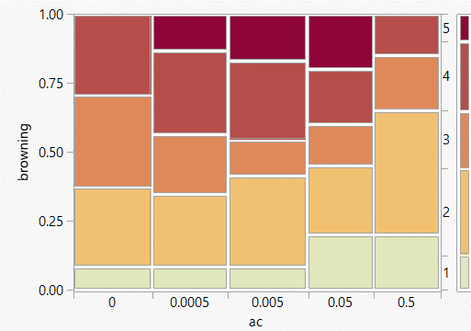
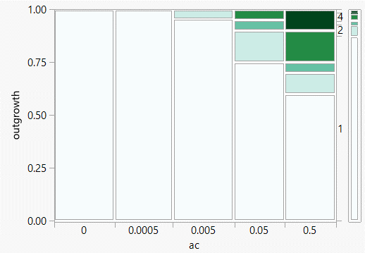
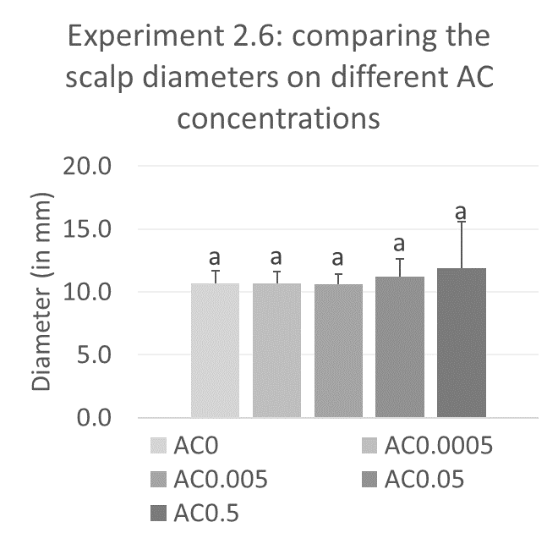
In the case of initiation, AC inhibited the meristematic proliferating effect that TDZ induces. The controls (no AC) resulted in 7 (20%) of the 35 initiated plantlets reacting. This suggest that 1g L-1 AC absorbs TDZ thus preventing the initiation of proliferation as observed in earlier reports (Wilms et al., Submitted). This absorbing effect of AC has been observed with many other plant growth regulators such as with BA and 2,4-D (Ebert and Taylor, 1990; Weatherhead et al., 1978). To overcome this, lower activated charcoal or increased PGR concentrations were tested on proliferating clumps. Varying the TDZ concentration (1, 10 or 100 µM) resulted in no significant differences in the amount of growth, outgrowth or browning. This suggest that there is a limit on the effects/toxicity that is caused by TDZ, which could potentially be explained by one of the working mechanisms of TDZ. TDZ is known to be able to bind and inhibit enzymes linked to cytokinin oxidase/dehydrogenase (Kopecný et al., 2010) causing an accumulation of endogenous cytokinins. If all sites are saturated, an increased concentration will not result in additional effects. However more studies should be executed before making a definite conclusion as TDZ has also been found to bind to other sites (Nisler, 2018). While the effect of TDZ concentration was not significant, the AC concentration had a significant impact on outgrowth/regeneration of plantlets, with higher concentrations of AC scoring significantly higher on the amount of outgrowing meristems, as even 0.005 g L-1 AC was able to induce a response (figure 1). However, no significant differences regarding browning or plant growth were observed (figure 1). This means that the usage of activated charcoal in this context doesn’t provide the same anti browning benefits compared to the ones it provides in coconut somatic embryogenesis (Sáenz et al., 2010), suggesting the need to use other browning preventative measures.

Figure 1: The effect of the different AC concentrations on the diameter (in mm), different letters represent a significant difference according to the Wilcoxon Each Pair method with α=0.05. The error bars represent the standard deviation of the corresponding data (left). The outgrowth score (middle) and browning score (right) of clumps of proliferating meristems after three weeks on the different media. Darker colours correspond with higher outgrowth and browning scores.

The effect of STS and ascorbic acid on proliferation
Regardless the concentration, ascorbic acid resulted in the same amount of browning, resulting in a model (figure 2) with a non-significant slope. This is somewhat unexpected as ascorbic acid prevented browning of tissue culture plants in multiple cases (Misra et al., 2010; Vijayalakshmi and Shourie, 2016).
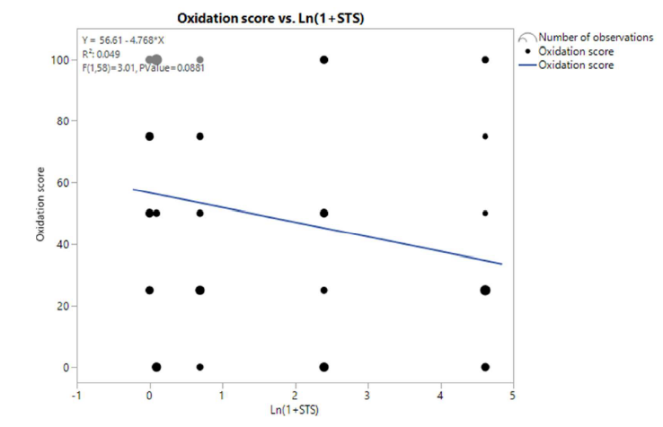
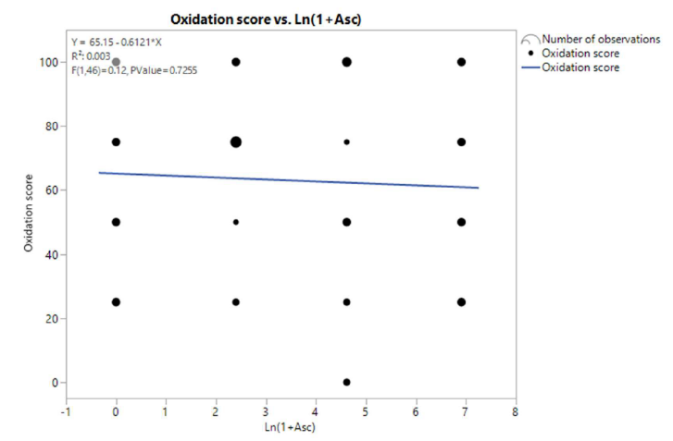
The higher the silver thiosulfate (STS) concentration, the less browning was observed, however, the model’s slope was not significantly different from a slope of 0 with a P value of 0.0881. STS is a compound that inhibits the ethylene signaling pathway of the plant (Serek et al., 2015; Veen and van de Geijn, 1978) and as such protects against oxidative stress, delays senescence and reduces the frequency of subcultures (Pimenta et al., 2013). This component therefore has the potential to be used instead of activated charcoal, with the advantage that no components are adsorbed.

Figure 2: Linear fit between the weighted score of oxidation and ln(1+[Asc]) Left and ln(1+[STS]) Right. The size of the points is an indication of the number of observations, ranging from 1 to 6.

The effect of light during regeneration and proliferation
About five months after the experiment was initiated, we observed that the media upon which the proliferating meristems were grown, played a role in browning. With especially high concentrations of NAA or 2,4D resulting in significant amounts of necrosis. The other media treatments were not significantly different from the control. However, light showed to be the most important factor in the experiment as the regenerating proliferating meristems that initially were kept in the dark for 3 months showed 24.8% necrosis compared to the 69.7% necrosis of the ones that were already put into the light after 1 month. As this browning happened mainly in the beginning of the experiment, we could assume that the same would apply to proliferating meristems. This suggests that these regenerating meristems during the early phase and, by extrapolation, proliferating meristems are light sensitive. Reports on photooxidation in literature are scarce as most plantlets are grown in the light or light dark cycle. There are some exceptions; for example many cryopreservation protocols make use of a dark phase following recovery after exposure to liquid nitrogen (Panis et al., 2005; Wilms et al., 2020). Also dark conditions are used during the proliferation of bananas via proliferating meristems (Strosse et al., 2008). A detailed comparative study is lacking and could be a great asset in defining light sensitive species/tissues. A possible explanation for the negative effect of light on the always white proliferating meristems is the lack of chloroplasts (and other plastids) which normally eradicate free radicals in the cell. This type of stress can of course be prevented by limiting the amount of light.

The effect of subculture period on browning during proliferation
While performing the STS and ascorbic acid experiments we observed that most browning occurred after 3 weeks since their last subculture (figure 3). This gives us the opportunity to prevent browning by shortening the subculture cycle. However, this drastically increases the labor to maintain and multiply the tissues and might not be considered an ideal solution.
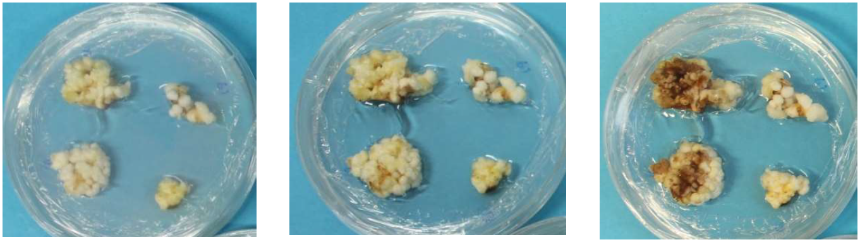
Figure 3: Browning on one of the 1µM TDZ controls after subculture. Pictures are made 1 week (left), 2 weeks (middle) and 3 weeks (right) after the start of the culturing cycle.

CONCLUSION
In this study we showed the importance of photooxidation during tissue culture and how to resolve it. Next to photooxidation, we have proven that the use of activated charcoal comes with an important drawback as it limits proliferation while having a non-significant effect on the severity of browning. In contrast, STS, which did not impact regeneration, is a promising anti-browning agent. However, more validation is needed to confirm this. And lastly, timing of subculture might be the most important factor as timely subculture can prevent most browning, however this is also the most labor-intensive solution.

ACKNOWLEDGEMENTS

This study was carried out with the support of “Research Program for Agricultural Science & Technology Development (Project No.PJ012225)” of International Cooperative Research Project in National Institute of Agricultural Sciences, Rural Development Administration, Republic of Korea.

We also gratefully acknowledge the Directorate-General Development Cooperation and Humanitarian Aid, Belgium (DGD) for the financial support of the project ‘Safeguarding vegetatively-propagated crop diversity to nourish people now and in the future’.

We want to acknowledge The Philippine Coconut Authority (PCA) and more specifically Dr. Ramon Rivera for providing us with the plant material that was used in this project.

LITERATURE CITED

Akhtar, R. (2019). Extreme weather events and human health: International case studies (Springer International Publishing).
Bandyopadhyay, R., and Frederiksen, R.A. (1999). Contemporary global movement of emerging plant diseases. Ann. N. Y. Acad. Sci. 894, 28–36.
Bene, S., Courbet, P., Dziwormu, A., Salinier, J., and Mensah-Bonsu, A. (2009). La filière du cocotier au Ghana et au Nigéria. Oléagineux Corps Gras Lipides 16, 87–96.
Caren, C.B., Cecilia, M.M., and Aggrey, B.N. (2019). In vitro regeneration of coconut (Cocos nucifera L) through indirect somatic embryogenesis in Kenya. African J. Biotechnol. 18, 1113–1122.
Ebert, A., and Taylor, H.F. (1990). Assessment of the changes of 2,4-dichlorophenoxyacetic acid concentrations in plant tissue culture media in the presence of activated charcoal. Plant Cell. Tissue Organ Cult. 20, 165–172.
Eeuwens, C.J. (1976). Mineral requirements for growth and callus initiation of tissue explants excised from mature coconut palms (Cocos nucifera) and cultured in vitro. Physiol. Plant. 36, 23–28.
Engelmann, F., Malaurie, B., and N’Nan, O. (2011). In vitro culture of coconut (Cocos nucifera L.) zygotic embryos. In Plant Embryo Culture: Methods and Protocols, T.A. Thorpe, and E.C. Yeung, eds. (Totowa, NJ: Humana Press), pp. 63–72.
Eziashi, E., and Omamor, I. (2010). Lethal yellowing disease of the coconut palms (Cocos nucifera L.): An overview of the crises. African J. Biotechnol. 9, 9122–9127.
FAO (2021). FAOSTAT.
Gunn, B.F., Baudouin, L., and Olsen, K.M. (2011). Independent origins of cultivated coconut (Cocos nucifera L.) in the old world tropics. PLoS One 6, 1–8.
Karun, A. (2017). Coconut Tissue Culture: The Indian initiatives, experiences and achievements. CORD 33, 14–24.
Kim, H.H., Lee, H.E., Cueto, C., Rivera, R.L., Han, B.H., Kwon, S.W., Baek, H.J., Park, H.J., and Rhee, J.H. (2019). Bacterial contamination in cryopreservation of coconut zygotic embryos. Acta Hortic. 1234, 65–72.
Kopecný, D., Briozzo, P., Popelková, H., Sebela, M., Koncitíková, R., Spíchal, L., Nisler, J., Madzak, C., Frébort, I., Laloue, M., et al. (2010). Phenyl- and benzylurea cytokinins as competitive inhibitors of cytokinin oxidase/dehydrogenase: a structural study. Biochimie 92, 1052–1062.
Misra, P., Toppo, D.D., Gupta, N., Chakrabarty, D., and Tuli, R. (2010). Effect of antioxidants and associate changes in antioxidant enzymes in controlling browning and necrosis of proliferating shoots of elite Jatropha curcas L. Biomass and Bioenergy 34, 1861–1869.
Mu, Z. (2020). Optimization of coconut micropropagation via somatic embryogenesis. In Proceedings, (MDPI AG), p. 55.
Nisler, J. (2018). TDZ: Mode of action, use and potential in agriculture. in thidiazuron: From urea derivative to plant growth regulator, N. Ahmad, and M. Faisal, eds. (Singapore: Springer Singapore), 37–59.
Panis, B., Piette, B., and Swennen, R. (2005). Droplet vitrification of apical meristems: A cryopreservation protocol applicable to all Musaceae. Plant Sci. 168, 45–55.
Pimenta, M., Ribeiro, C., Soares, C., Mendes, G., Braga, V., Reis, L., Otoni, W., Resende, C., Viccini, L., and Peixoto, P. (2013). Ethylene synthesis inhibition effects on oxidative stress and in vitro conservation of Lippia filifolia (Verbenaceae). Brazilian J. Biol. 73, 617–621.
Punchihewa, P.G., and Arancon, R.N. (1999). Coconut post-harvest operations (Food and Agriculture Organization of the United Nations).
Rajesh, M.K., Karun, A., and Parthasarathy, V.A. (2019). Coconut biotechnology. In The coconut palm (Cocos nucifera L.) - research and development perspectives, K. Nampoothiri, V. Krishnakumar, P. Thampan, M. Nair, eds. (Springer, Singapore), 191-226.
Research and markets (2019). Coconut products market by type application and form: Global opportunity analysis and industry forecast, 2019-2026.
Rillo, E.P., Cueto, C.A., Medes, W.R., and Areza-libaldo, M.B. (2002). Development of an improved embryo culture protocol for coconut in the Philippines. In Coconut Embryo in Vitro Culture: Part II, F. Engelmann, P. Batugal, and J. Oliver, eds. (Rome: IPGRI-APO), pp. 41–65.
Rival, A., Ilbert, P., Labeyrie, A., Torres, E., Doulbeau, S., Personne, A., Dussert, S., Beulé, T., Durand-Gasselin, T., Tregear, J., et al. (2013). Variations in genomic DNA methylation during the long-term in vitro proliferation of oil palm embryogenic suspension cultures. Plant Cell Rep. 32, 359–368.
Sáenz, L., Herrera-Herrera, G., Uicab-Ballote, F., Chan, J.L., and Oropeza, C. (2010). Influence of form of activated charcoal on embryogenic callus formation in coconut (Cocos nucifera). Plant Cell. Tissue Organ Cult. 100, 301–308.
Serek, M., Sisler, E.C., and Mibus, H. (2015). Chemical compounds interacting with the ethylene receptor in ornamental crops. Acta Hort. 1060, 23–29.
Sisunandar, Sopade, P.A., Samosir, Y.M.S., Rival, A., and Adkins, S.W. (2010). Dehydration improves cryopreservation of coconut (Cocos nucifera L.). Cryobiology 61, 289–296.
Sisunandar, Novarianto, H., Mashud, N., Samosir, Y.M.S., and Adkins, S.W. (2014). Embryo maturity plays an important role for the successful cryopreservation of coconut (Cocos nucifera). Vitr. Cell. Dev. Biol. - Plant 50, 688–695.
Strosse, H., Andre, E., Sági, L., Swennen, R., and Panis, B. (2008). Adventitious shoot formation is not inherent to micropropagation of banana as it is in maize. Plant Cell. Tissue Organ Cult. 95, 321–332.
Vadamalai, G., Perera, A.A.F.L.K., Hanold, D., Rezaian, M.A., and Randles, J.W. (2009). Detection of coconut cadang-cadang viroid sequences in oil and coconut palm by ribonuclease protection assay. Ann. Appl. Biol. 154, 117–125.
Van den Broeck, I., Ludikhuyze, L., Weemaes, C., Van Loey, A., and Hendrickx, M. (1998). Kinetics for isobaric−isothermal degradation of l-ascorbic acid. J. Agric. Food Chem 46, 2001–2006.
Veen, H., and van de Geijn, S.C. (1978). Mobility and ionic form of silver as related to longevity of cut carnations. Planta 140, 93–96.
Vijayalakshmi, U., and Shourie, A. (2016). Remedial effect of ascorbic acid and citric acid on oxidative browning of Glycyrrhiza glabra callus cultures. BioTechnologia 97, 179–186.
Weatherhead, M.A., Burdon, J., and Henshaw, G.G. (1978). Some effects of activated charcoal as an additive to plant tissue culture media. Zeitschrift Für Pflanzenphysiologie 89, 141–147.
Welewanni, I., and Bandupriya, D. (2017). Coconut cryopreservation: Present Status and Future Prospects. CORD 33, 41–61.
Wilms, H., De Bièvre, D., Longin, K., Swennen, R., Rhee, J., and Panis, B. (Accepted; 2021) Development of the first axillary in vitro shoot multiplication protocol for coconut palms. Sci. Rep.
Wilms, H., Rhee, J.H., Rivera, R.L., Longin, K., and Panis, B. (2019). Developing coconut cryopreservation protocols and establishing cryo-genebank at RDA; a collaborative project between RDA and Bioversity International. Acta Hortic. 1234, 343–348.
Wilms, H., Sleziak, N.F., Van der Auweraer, M., Brands, M., Verleije, M., Hardeman, D., Andre, E., and Panis, B. (2020). Development of a fast and user-friendly cryopreservation protocol for sweet potato genetic resources. Sci. Rep. 10, 14674.

