ILRI “Wild Meat” Report: Q&A Sheet + Infographics
This Q&A sheet summarizes 14 key aspects of the 2024 ILRI Wild Meat Report to provide a clear understanding of the wild meat trade, its implications, and potential solutions. For further details, refer to:
Full report: Eating wild animals: Rewards, risks and recommendations
https://cgspace.cgiar.org/items/1ca9e796-ad7a-4e7d-8bad-5e0a4867ee43
Research brief: Eating wild animals: Rewards, risks and recommendations
https://cgspace.cgiar.org/items/5e005733-e3cf-42d9-a947-35276fac710c
News article: Eating wild animals: The rewards are as big as the risks
https://www.ilri.org/news/eating-wild-animals-rewards-are-big-risks
Slide presentation: Launch of ILRI Report: Eating wild animals—rewards, risks and recommendations
https://cgspace.cgiar.org/server/api/core/bitstreams/ef022acd-989a-40b6-9f63-ff83d81bd5ba/content
Infographics: ILRI Flickr
https://www.flickr.com/search/?user_id=7155605%40N03&sort=date-taken-desc&text=%22wild+meat%22&view_all=1

14 Q&As

01 What is the focus of this new report?
This report primarily examines the uses of wild meat in East Asia (China and Mongolia), Southeast Asia, and sub-Saharan Africa. It synthesizes evidence on wildlife meat consumption and its associated biodiversity and zoonotic risks. The report provides recommendations for organizations in health, veterinary, environment, and wildlife sectors to mitigate these risks. The focus is on actors in the wild meat trade, their behaviors, and the driving factors behind wild meat practices.

02 What is the 'wild meat trade'?
‘Wild meat’ refers to animal wildlife used for food and non-food purposes, including medicinal uses. The wild meat value chain includes hunting, selling, and consumption, with key actors such as hunters, farmers, traders, butchers, retailers (e.g., restaurants, traditional medicine shops, exotic pet markets), and consumers.
The trade involves domestic rural consumption, rural-to-urban marketing, and a significant high-value, often illicit, export trade. In many developing regions of Asia, Africa, and Latin America, hunting remains a vital source of food, income, and traditional medicine. Wild meat is sourced from various species, including mammals, birds, reptiles, amphibians, fish, and invertebrates.

03 What’s the history of the wild meat trade?
Early hominins in East Africa incorporated more meat and bone marrow into their diets around three million years ago, supporting brain development and complex societies. In Asia, prehistoric hunters used tools and strategic methods to capture prey.
A dietary shift occurred with livestock domestication in the Neolithic period (~9,000 BC). Goats, sheep, cattle, and pigs became primary meat sources. In Neolithic China, wildlife consumption transitioned to domesticated species, though wild meat remained common into the Bronze Age.
In Africa, European colonization (17th century) introduced firearms and transportation methods that intensified hunting, leading to significant wildlife depletion. By the 12th–16th centuries, wild meat consumption peaked in England but later declined due to changing cultural perspectives.

04 What’s the size of the wild meat trade?
- Prevalence: Hunting is widespread in Latin America and Africa. Across 24 Global South countries, 39% of households consume wild meat (~150 million households).
- Economic Value: Estimated at USD 1 billion annually in Africa; the illegal trade in Southeast Asia is valued at USD 8–11 billion.
- Volume Extracted: Between 1–5 million metric tonnes (mt) per year in Africa, compared to 14 million mt of livestock meat. In some African countries, wild meat extraction matches livestock meat supply.
- Challenges in Estimation: The trade is largely unregulated and underreported due to its informal nature.

05 How do wild meat value chains differ in Africa and Asia?
- Africa: Wild meat is essential for sustenance due to protein scarcity; hunting is driven by necessity.
- Asia: Wild meat is often a luxury, consumed for celebratory or medicinal purposes. High demand has led to wildlife farming, a practice now under scrutiny due to zoonotic risks.
- Price & Rarity: In Asia, rarity increases market value, unlike in Africa where affordability drives consumption.

06 Who eats wild meat and how much do they eat?
- Africa: Central Africans consume an average of 35 kg of wild meat annually, often surpassing livestock meat consumption.
- Asia: In rural areas with hunting access, consumption is around 20 kg per year.
- Demographics: Rural dwellers, men, and older populations consume more wild meat than urban residents, women, and youth.

07 What’s the future of the wild meat trade?
- Growth Uncertainty: Some argue wild meat trade is expanding; however, data is inconclusive.
- Zoonotic Pandemics: The impact varies—some countries see increased demand post-pandemics, others a decline.
- Climate Change: May increase wild meat reliance by reducing alternative protein availability.
- Wildlife Farming: Growing in Asia, raising concerns about wildlife laundering and zoonotic disease risks.

08 What role does wild meat play in food and economic security?
- Nutritional Value: Rich in proteins, micronutrients, and energy. In 62 countries, wild meat provides at least 20% of rural household protein.
- Economic Importance: Not a primary income source for most, but essential in regions with high trade activity. Hunters and traders profit significantly in some locations.
- Food Security Risks: Removing wild meat could exacerbate food insecurity in at least 15 African nations.

09 How is wild meat used in medicine?
- Zootherapy: Over 2,000 medicinal practices documented, using ~521 mammalian species.
- Consumption for Health: In China, 70% of rural and 30% of urban households consume wild meat for medicinal purposes.

10 How does the wild meat trade impact biodiversity?
- Unsustainable Hunting: Many species are over-harvested, with large mammals often hunted out first.
- Conservation Efforts: Protected areas and anti-poaching regulations exist but face enforcement challenges.
- Wildlife Laundering: Legal markets for farmed wildlife can enable the illegal trade of wild-caught animals.

11 What is wildlife farming?
- Common in Asia, Rare in Africa: Asia has embraced wildlife farming, especially for food and medicine.
- Economic Motivation: High demand for exotic meat and medicinal products drives farming.
- Challenges: Risk of zoonotic diseases, wildlife laundering, and biodiversity threats.

12 How does the illegal wild meat trade operate?
- Online Expansion: Illegal sales increasingly occur on platforms like Facebook and WhatsApp.
- Luxury Markets: Upscale restaurants cater to wealthy consumers, offering exotic wildlife dishes.
- Food Fraud: Wild meat is often mislabeled and sold as other meats, misleading consumers.

13 What role does wild meat play in zoonotic disease outbreaks?
- Transmission Routes: Direct contact with animals, handling/butchering, or consumption.
- High-Risk Species: Primates, rodents, bats, and carnivores carry significant zoonotic pathogens.
- Pandemic Links: Many global disease outbreaks, including COVID-19, originated from wildlife or wildlife farming.

14 How can the wild meat trade be better managed?
- Bans & Regulation: Enforced in some African nations but limited elsewhere.
- Community-Based Approaches: Engage local populations in conservation efforts.
- Alternative Proteins: Promote farmed mini-livestock like guinea pigs, cane rats, and capybaras.
- Consumer Behavior Changes: Utilize food disgust and neophobia to reduce wild meat demand.

11 Infographics
Infographic 01
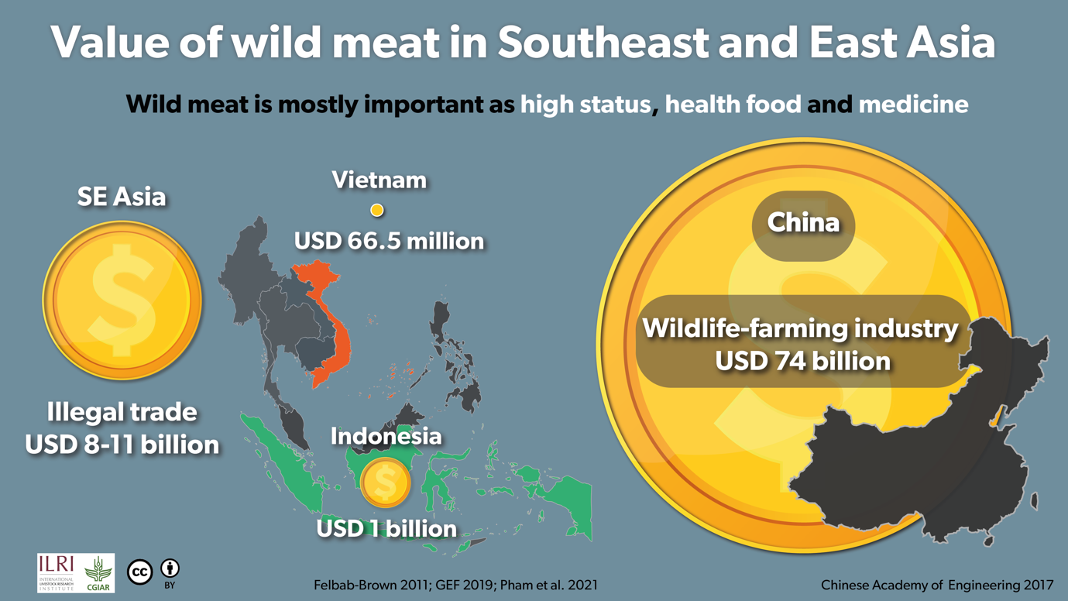
Infographic 02
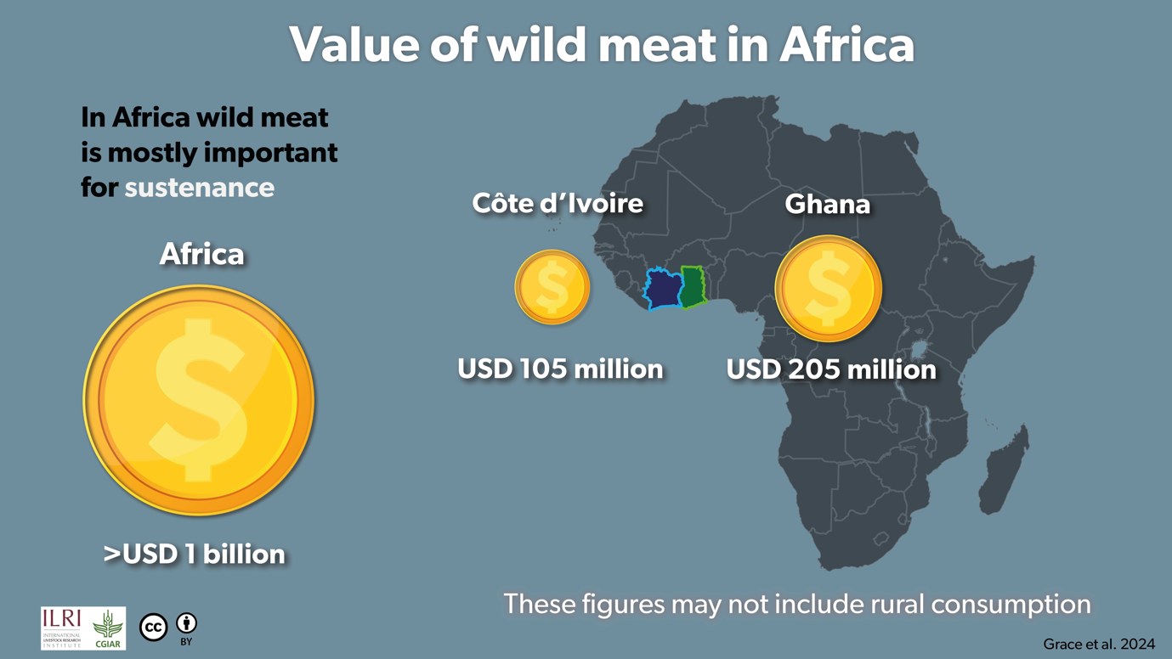

Infographic 03
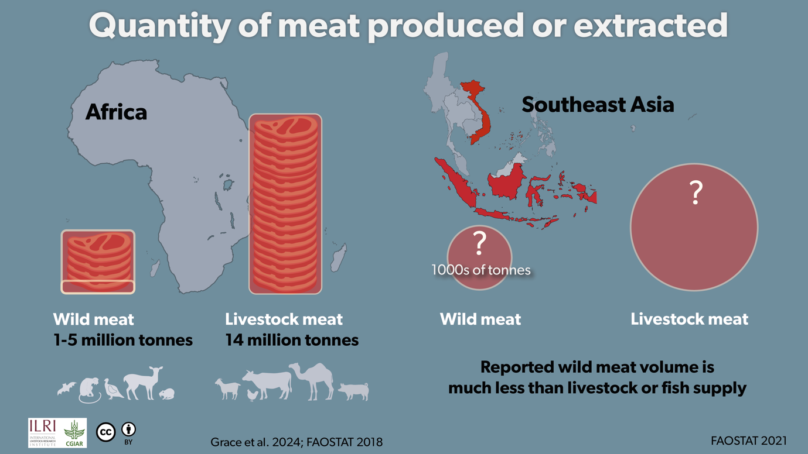
Infographic 04
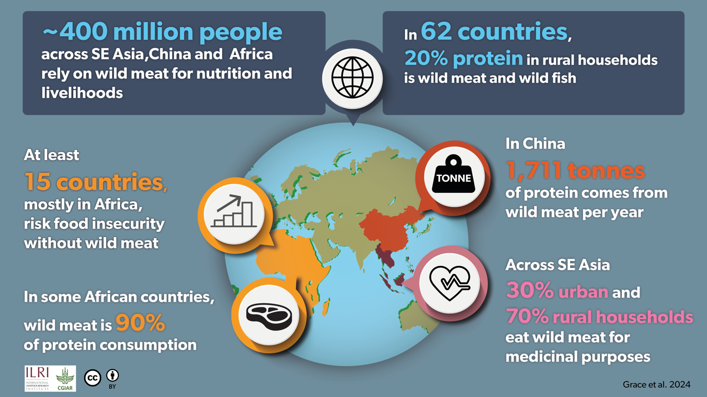

Infographic 05
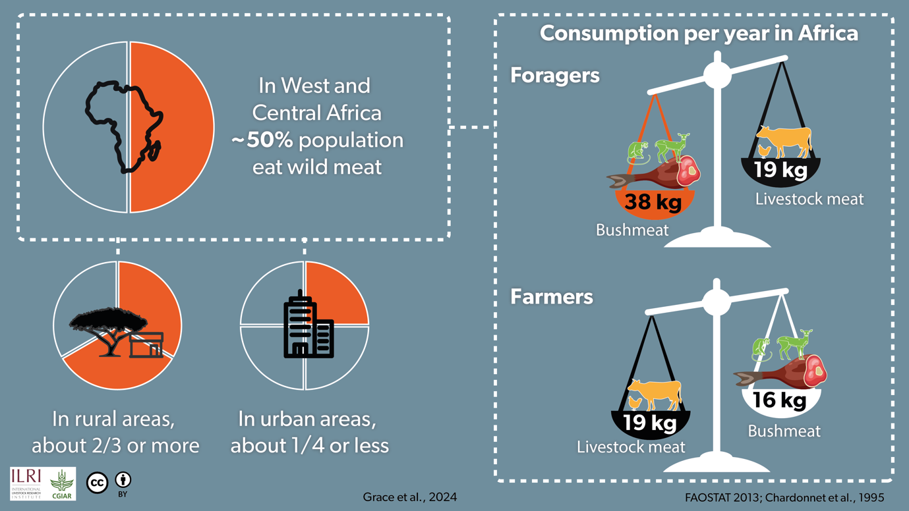
Infographic 06
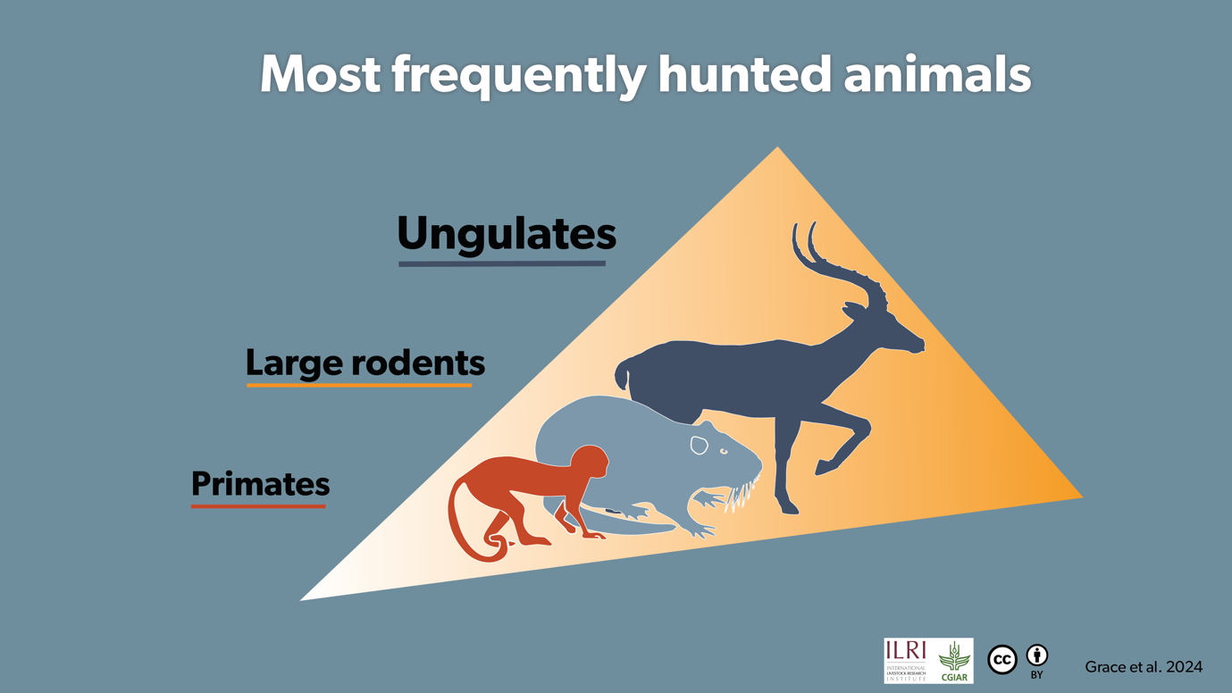

Infographic 07
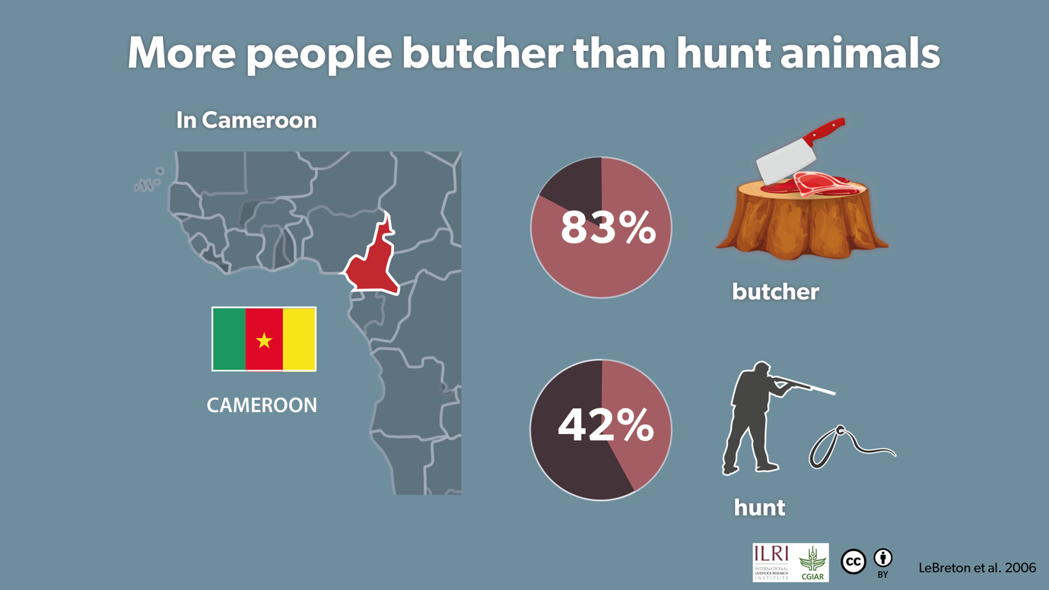
Infographic 08
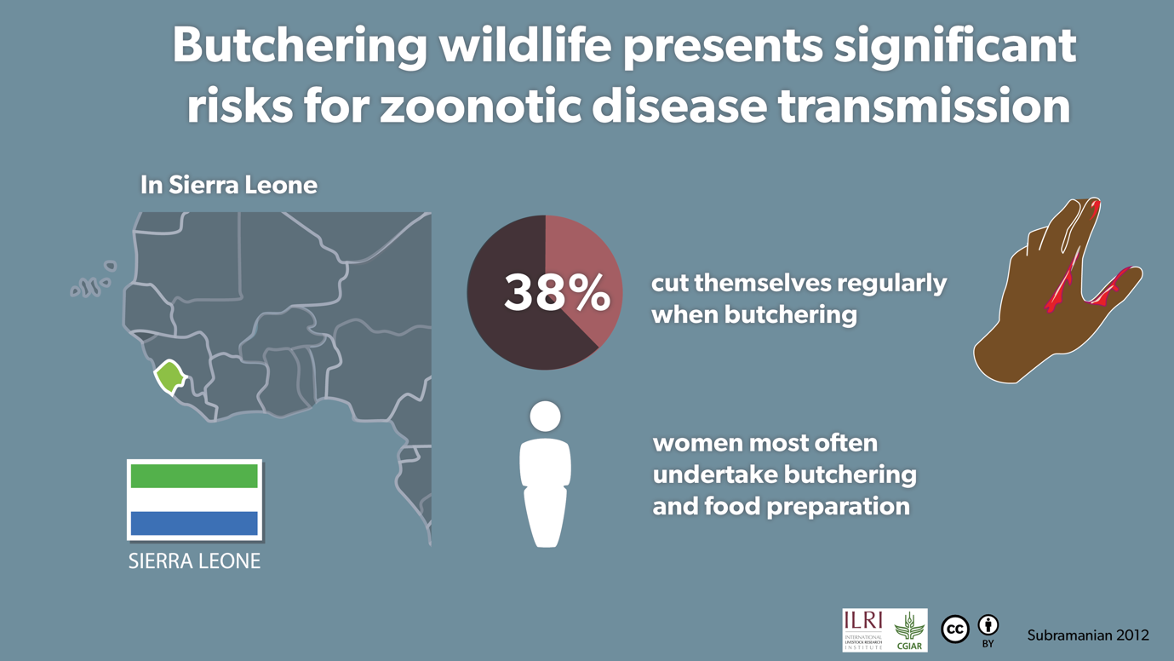

Infographic 09
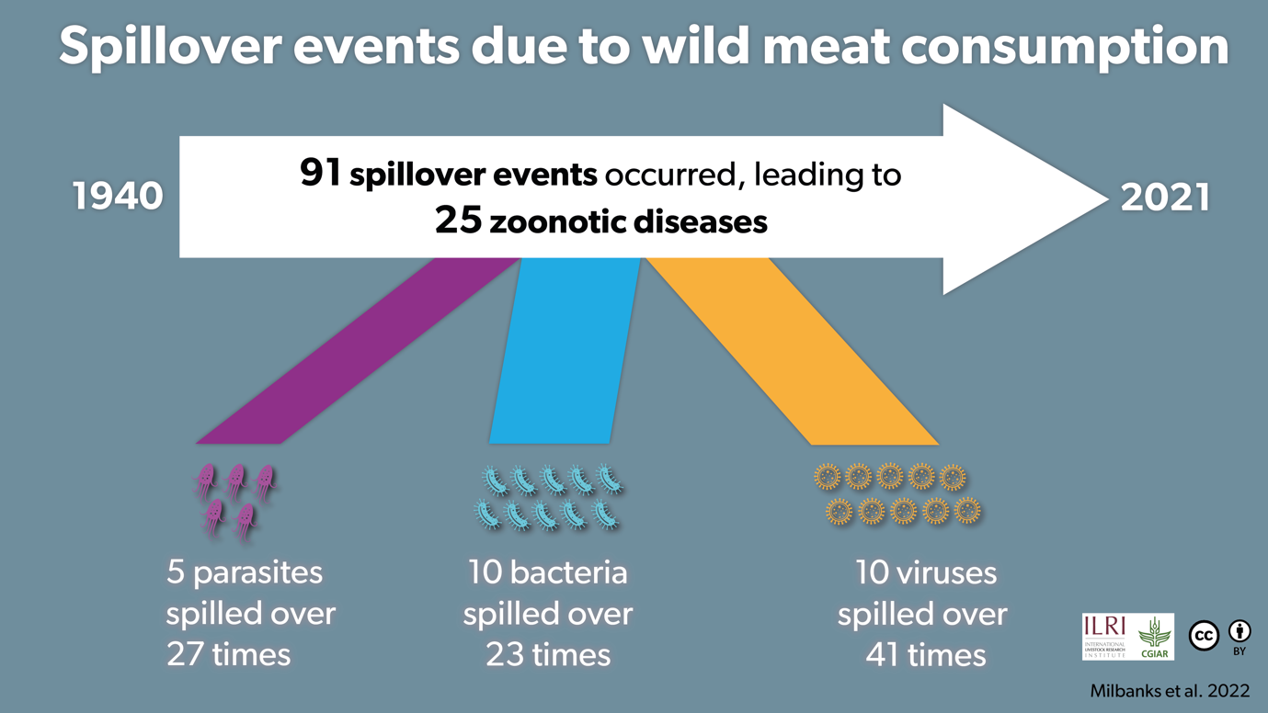
Infographic 10
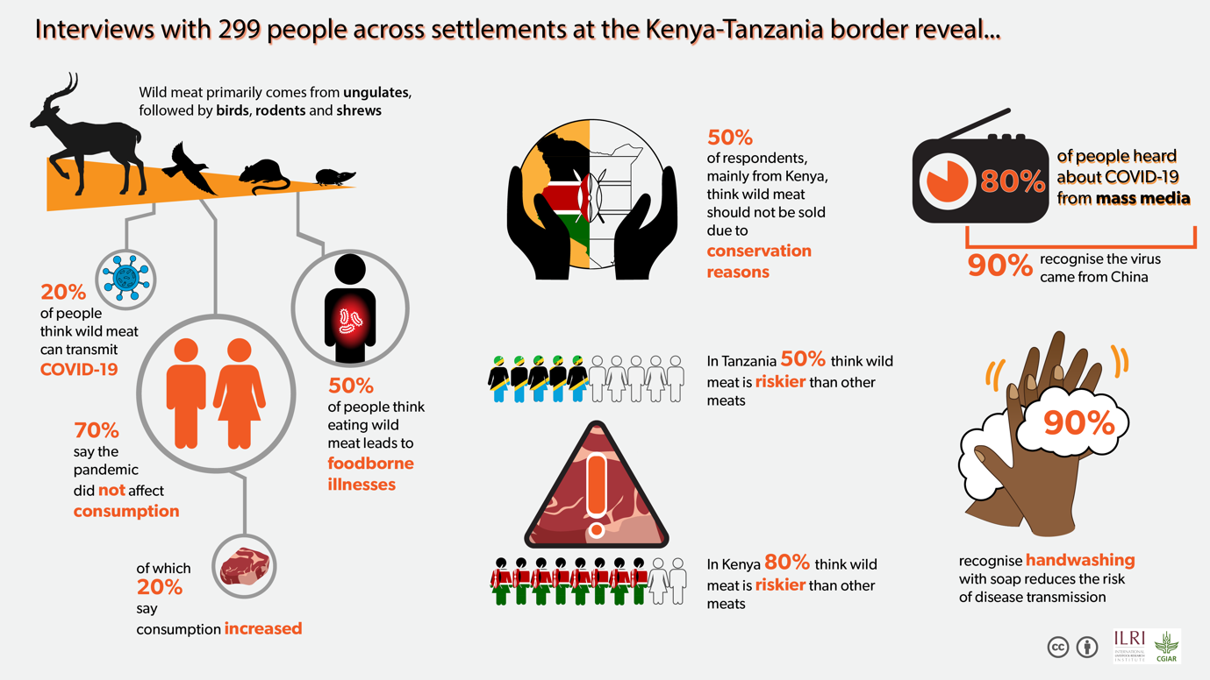

Infographic 11
