PROJECT

WATER AVAILABILITY, WATER USE AND TRENDS
IN SREPOK RIVER BASIN (VIETNAM)

WORKING PAPER

INTERACTION BETWEEN GROUNDWATER RESOURCES, AGRICULTURAL PRODUCTION AND WATER EXPLOITATION INFRASTRUCTURE IN SREPOK RIVER BASIN (VIETNAM)

HANOI, 2013

TABLE OF CONTENTS

I. INTRODUCTION 3
II. CHARACTERISTICS OF GROUNDWATER RESOURCES IN SREPOK RIVER BASIN 4
2.1. Porous aquifers 4
2.1.1. Porous aquifers in Holocene sediments (qh) 4
2.1.2. Porous aquifers in Pleistocene sediments (qp) 4
2.2. Cracked aquifers 5
2.2.1. Cracked aquifers in Neogene - Pleistocene eruptive basalts (Bn-qp) 5
2.2.2. Cracked aquifers in Neogene sediments (n) 6
2.2.3. Cracked aquifers in Jurassic sediments (j) 7
2.3. Geological formations with very poor or no water storage capacity 8
2.4. Potential exploitable groundwater reserves 8
III. STATUS OF GROUNDWATER EXPLOITATION AND USE SINCE 2005 IN SREPOK RIVER BASIN 11
3.1 Types and equipment of groundwater exploitation 11
3.2 Groundwater exploitation status 14
IV. WATER RESOURCE ENVIRONMENT QUALITY IN SREPOK RIVER BASIN 19
4.1 Basis for the evaluation of irrigation water quality 19
4.2. Overview of hydrological, geological and chemical characteristics 20
4.3. Groundwater quality 21
V. GROUNDWATER RESOURCE PROCESS IN SREPOK RIVER BASIN 29
5.1 Trend of groundwater fluctuation in Serepok river basin 29
5.2 Case study of interaction between surface water resource and groundwater in basalt area of Buon Ma Thuot. 38
5.2.1. Components of surface flow 40
5.2.2 Components of groundwater flow 43
5.2.3 Land exploitation and unitization 47
5.2.4. Calibration results of parameter sets of mathematical model– groundwater level (water tables) (m) 51
5.2.5. Quantitative and calculation results of processes of key components 53
5.3 Some main reasons to lower water table level: 59
VI. ORIENTATIONS OF WATER RESOURCE EXPLOITATION UP TO 2020 61
6.1. Orientations of groundwater exploitation 61
6.2. Orientations of rural water supply 62
6.3. Orientations for industrial water supply 63
VII. REFERENCE 65

INTRODUCTION
The Srepok River Basin is located in the Central Highlands, which is of strategic importance in terms of socio- economy and national defense - security, possesses advantages for the development of agriculture, forestry, large-scale cash production combined with processing industry, power industry and mining industry development. There was strategy and plan to build an economically prosperous Central Highlands, powerful defense and security towards a dynamic economic region. Assessment of water resources and effective water exploitation and use in the Central Highlands is urgent because of abnormal climatic conditions with more frequently floods and droughts happened in recent years.
In the past decades, the exploitation and use of water resources (surface and groundwater) and the prevention and control of water-caused disasters in the Srepok River Basin have gained important achievements, contributing greatly to socio-economic development of the basin.
However, we have not been fully aware in a long time of the meaning and importance of sustainable water resources exploitation and use for socio-economic development, life, health and environment, we have not paid enough attention to the management and protection as well as planning of water resources utilization. This led to degradation of water resources in both quantity and quality; water pollution, water shortage, water scarcity occurred in many places and tend to increase in recent years.
Wastefulness, inefficiency, lack of planning, lack of intersectoral coordination in water use is still quite common in the basin. Meanwhile, water demand of economic sectors is constantly increasing, water balance between supply and demand are not met in many times and many places, causing important pressures on industrialization and modernization of the localities in the Srepok basin which face also increasing population and impacts of global climate change.

CHARACTERISTICS OF GROUNDWATER RESOURCES IN SREPOK RIVER BASIN

2.1. Porous aquifers

2.1.1. Porous aquifers in Holocene sediments (qh)
The porous aquifers in the Holocene sediments (so called as the aquifers qh) are formed by fluvial, fluvial-marsh sediments found along the valleys of the Ea Krong Ana, Ea Krong Pach, Dak Krong, Ea H'leo rivers. Their petrographic composition is mainly sand, plasters, clay, and gravel. The thickness varies widely in the range of 0.5 to 30 m, usually 3 to 5 m.
Water in these aquifers is unconfined water. Static water table is usually found at 0.8 to 6.6 m depth, commonly from 1.5 to 2.0 m. Experimental results showed that flow rate in boreholes varies from 0.05 to 0.33 l/sm but often less than 0.2 l/sm, water flow in open springs is 0.3 to 0.4 l/s. The porous aquifers in the Holocene sediments are of water poor category. In the Krong Pach - Lak area, some boreholes have flow of 1.0 to 9.02/s, belonging mainly to the medium water availability category.
The mineral contents are usually from 0.12 to 0.25 g/l, belonging to the insipid water type. Main chemical characteristics are sodium - magnesium bicarbonate and sodium bicarbonate.
The main supply for the aquifers qh is local rainwater and permeable river water; the drainage area is the local intrusive network.
In general, the porous aquifers in the Holocene sediments have small thickness, are narrowly distributed and belong to the water poor category, so they are not significant for water supply. Exceptionally for the Krong Pach - Lak hollow where the sediments have high thickness and medium water storage capacity so they are potential for water supply.

2.1.2. Porous aquifers in Pleistocene sediments (qp)
The porous aquifers in the Pleistocene sediments (aquifers qp in short) are mainly distributed along the valleys of Ea H'leo, Dak Krong and Ea Sup rivers on an area of ​​about 25 km². The main compositions are gravel, clay and plaster. The thickness varies from 8 to 9 m.
Water in the aquifers qp is unconfined water or weakly confined water in some places. Water table is usually found at 2.0 to 4.0 m under the ground. Flows in dug wells range from 0.1 to 1.5 l/s, frequently at 0.3 to 0.5 l/s. Field surveys have found some open springs with water flows from 0.05 to 0.8 l/s, often 0.2 to 0.4 l/s. So the Pleistocene sediments are poor in terms of water availability, some places have high thickness and have medium storage capacity.
Groundwater is mainly sodium bicarbonate, chloride sodium and sodium bicarbonate. Mineral contents are 0.03 to 0.52 g/l, commonly from 0.1 to 0.25 g/l belonging to insipid water category.
The supply sources for the aquifers qp are rainwater directly fallen on the open springs, permeable water from the aquifers qh and surface water. Water dynamics change seasonally with water level variation of about 1.5 to 3.0 m.
In summary, the aquifers in Pleistocene sediments are narrowly and scattered distributed the thickness is small, water storage capacity is poor so they can only meet small-scale and household-scale water supply.

2.2. Cracked aquifers

2.2.1. Cracked aquifers in Neogene - Pleistocene eruptive basalts (Bn-qp)
These aquifers are composed of Tuc Trung strata (B/N₂-Q₁tt), Dai Nga strata (B/N₂đn) and Xuan Loc strata (B/Q₁²xl) which are widely distributed across the Buon Ma Thuot plateau, and Chu Puh, Chu Se districts in the South of Gia Lai province (northeast of Srepok River Basin) and Dak Mil district of Dak Nong province (southwest of Srepok River Basin). The stone texture is solid with pores and unevenly fractured, the upper part is totally weathered to become red soils. The thickness of the weathering crust is commonly 5.0 to 15.0 m. The thickness of the eruptive basaltic formations varies from 40 to 250 m, often from 80 to 120 m.
Water is belongs to groundwater category, sometimes locally unconfined water. In the Duc Co, Bau Can areas, water level is usually found at 3 to 12 m under the ground, the Ea H'leo at 5 to 10 m, the Buon Ho - Quang Nhieu area 3 to 8 m; Phuoc An area at 8 m to 12 m, the Buon Ma Thuot are at 7 to 15 m, and the Dak Mil area 3 to 10 m. In some areas, groundwater level is very low down to 74 m (Chu Ty - Duc Co) or 80 m (Dlei Yang - Ea Hleo).
Groundwater in the eruptive basalts Bn-qp is rather abundant. Results from experimental boreholes show water storage capacity of basalts varies widely from poor to high. Results of groundwater exploration and investigation revealed that 60% of boreholes have moderate to very high water availability, including 14% of boreholes having very high water availability. The poor boreholes are usually found in Chu Se, Chu Puh (Gia Lai province); Ea H'leo, along the edges of the Buon Ho - Quang Nhieu, in the South of Buon Ma Thuot city (Dak Lak province); and Dak Mil (Dak Nong province). The rich to very rich boreholes are usually found in the central Phuoc An, in Dat Ly, Hoa Binh, CuM'gar areas, etc.
The open springs usually run out from crusted spherical-shaped, weathered and fractured basalts. Water flows at the open springs vary largely but frequently from 1.5 to 5.0 l/s, in particular water flows reach to 80.62 l/s at the cluster of open springs No. 4 (Phuoc An); minimum flow is 50 l/s at the cluster of open springs No. 3 (Co Tam) and 25.6 l/s at the cluster of open springs No. 9 (Buon Ho).
One notable remark is that when drilling down to more than 50 m in the southwest area of Buon Ho town, the water flowing down to the boreholes fully disappears. When closing the boreholes to the depth of 40 - 50 meters, water level rises to near the ground. Therefore, water extraction boreholes in this area should not be deeper than 40-45 m.
Water in eruptive basalts has mineral contents from 0.1 to 0.7 g/l, frequently from 0.2 to 0.4 g/l, and is classified as insipid water. Chemical characteristics are mainly sodium bicarbonate, sodium-magnesium bicarbonate, and magnesium-sodium bicarbonate. Several boreholes has high mineral contents of water (M = 1.33 to 1.75 g/l) which is categorized as mineral water.
Water dynamics changes from season to season and is about 1.5 to 2 months dephased with the rainy periods. Every year, groundwater level rises maximally in the early rainy season at the end of the rainy season (September, October) and regresses minimally at the beginning or the rainy season (April, May). Difference of water levels between the two seasons depends on areas, specifically the difference is 0.5 to 5.7 m for Ea H'leo area; 0.3 to 3.0 m for the Buon Ho - Quang Nhieu area; 1.2 to 6.4 m for the northwest of Buon Ma Thuot, 0.8 to 2.4 m for the Dak Mil area; and from 0.5 to 2.0 m for the Chu Prong area (Gia Lai).
The main supply to the Bn-qp aquifers is rainwater directly fallen on the open parts and surface water drained to open locations and river networks.
In summary, the Bn-qp aquifers are widely distributed, have large thickness and high water availability and good quality water. This is the most important aquifers for Srepok River Basin which can meet the requirements of medium- to large-scale centralized water supply, especially for the Buon Ma Thuot plateau.

2.2.2. Cracked aquifers in Neogene sediments (n)
Aquifers in Neogene sediments (so called aquifers n) are found in the Krong Pach low-lying area, along the Ea Krong Pach River. They are covered by the Quaternary sediments and composed of conglomerate, sandstone, siltstone, claystone, clay coal, brown coal and are weakly coherent. The thickness varies from 10 to 50 m.
Groundwater in the Neogene aquifer is confined water, water level changes from erupting to +0.2 m on the ground to flowing 5.58 m under the ground, the common value is less than 1.0 m. Results of experimental pumping at boreholes showed that flow changes from 1.73 to 3.77 l/s, meaning the aquifers is poor to moderate, but often moderate.
Dynamics of groundwater in the Neogene sediments change very clearly from season to season; at the beginning of rainy season, groundwater reaches maximum level and decreases to the normal level about a month after rainy season. The groundwater difference between the two seasons is 2.0 to 2.4 m.
Chemical characteristics of water in the Neogene sediments are mainly chloride bicarbonate or sodium - magnesium bicarbonate. The mineral contents of water vary from 0.08 to 0.24 g/l, normally at less than 0.2 g/l belonging to insipid water.
Groundwater of these aquifers is directly supplied by rainwater for the open parts and by river water and seepage water from the upper aquifers (Holocene and Pleistocene aquifers).
Generally, Neogene aquifers are widely distributed, have considerable thickness but their storage capacity is just poor to moderate so can only meet small-scale water supply.

2.2.3. Cracked aquifers in Jurassic sediments (j)
These aquifers are composed of soils and stone of Ea Sup strata (J₂es), La Nga strata (J₂ln), Dray Linh strata (J₁đrl) and Dak Bung strata (J₁đb), hereunder referred to as aquifers j. They are widely distributed in Ea Sup, Buon Don, Krong Pach, Krong Ana (Dak Lak province); Krong No, Cu Jut, Dak Mil (Dak Nong province) and Chu Prong (Gia Lai province). Main compositions are sandstone, claystone, siltstone, and calcareous shale. Sediment thickness varies from 500 to 2,000 m.
Water in these aquifers belongs to groundwater category; the water level is at 2 to 5 m under the ground. Experimental drilling showed that flow changes from 0.4 to 4.26 l/s, corresponding to the flow rate varied from 0.02 to 0.46 l/sm, permeability coefficient from 0.059 to 3.96 m per day. Field survey results revealed a number of open springs with flows from 0.01 to 1.0 l/s, usually less than 0.5 l/s. Thus, the Jurassic sediments are of water-poor type.
Water in these aquifers has mineral contents from 0.258 to 0.61 g/l, usually from 0.3 to 0.4 g/l. PH is from 6.1 to 7.7. The chemical characteristics are sodium bicarbonate, sodium -magnesium bicarbonate. In Ea Sup, Buon Don, Cu Jut, Chu Prong areas, water usually has high hardness, ranging from 258 to 650 mgCaCO₃ per liter; in some places water is not good for drinking because of high water hardness which is resulted from disintegration of lime clay layers intercalated in Jurassic sediments and then increase the contents of of Ca₂ + and HCO₃⁻ in water.
The supply for these aquifers is rainwater on the open areas and penetrated water from eruptive basaltic aquifers which then drains to rivers and streams.
Generally, Jurassic aquifers in Srepok River Basin are widespread distributed, possesses large water storage thickness but poor water availability; water have high hardness at some places so it is only significant for small-scale water supply.

2.3. Geological formations with very poor or no water storage capacity
These include eruptive formations, eruptive sediments of Don Duong strata (K2đd), Mang Yang Formation strata (T₂mg), Chu Prong strata (P2-T₁cpr), Dak Lin strata (C3-P₁dl), metamorphosed sedimentary formations of Ia Ban strata (PPib) and intrusive magma. They constitute medium to high mountains with separated terrain. Those formations usually have very thin weathering layer, can store water but often dry up in dry season; the non-weathering part has sound structure with very few fractures and does not have storage capacity. Groundwater flows at some open springs are 0.01 to 0.5 l/s, most commonly at less than 0.1 l/s. There are very few number of research boreholes and flow rates are from 0.01 to 0.03 l/s. They all have very poor water storage capacity and can be seen as aquitards.
However, it should be noted that areas with tectonic faults where rocks are strongly fractured possesses good storage capacity and can be a good supply of water but reserves are not large.

2.4. Potential exploitable groundwater reserves
Srepok River Basin possesses relatively rich potentials in groundwater sources, notably and most importantly are the aquifers in the eruptive basaltic formations which are mainly distributed in the Buon Ma Thuot plateau (about 4,000 km²) and in the North of Dak Nong plateau (Dak Mil, Dak Song, Cu Jut) in the Srepok River Basin.
In terms of potentiality and capacity to exploit water resources in Srepok River Basin, there exist mainly two forms, i.e., porous or cracked aquifers.
Porous aquifers mainly occur on narrow areas along river valleys, large lakes, and low-lying areas like Krong Pach, Lak, etc, therefore porous water does not form continuous aquifers, but are distributed in separated areas. In each aquifer, depending on their characteristics of formations (riverbed, flood plains, fluvial terrace, grabens, etc) their features of groundwater storage and movement are different. Hydraulic properties in these aquifers are mainly unconfined water.
Cracked aquifers exist in the fractured rock of eruptive basaltic formations (forming important aquifers), sediments and eruptive sediments (forming poor and middle aquifers). Groundwater surface in fractured rock is often in the form of a stair. Water depth varies from 5 to 15m, or deeper in some places. Hydraulic properties are mainly of groundwater, sometimes of local confined water; the main supply is rainwater and surface water.
Groundwater reserves in Srepok River Basin were calculated from two constituents, i.e., natural static reserves and natural dynamic reserves.
Potential exploitable reserves can be formed from one or more sources. The sources forming potential exploitable reserves of groundwater may be natural dynamic reserves, artificial dynamic reserves, part of the static natural reserves, artificial static reserves and absorbed reserves formed during extraction.
Static natural reserves here are formed mainly in the fractured zones and hallows of basaltic formations, terrigenous formations and intrusive rocks. Fractured zones and hallows of basaltic formations have large thickness so they have a significant volume of static reserves while other formations are less usable, partly due to incomplete research and partly because of small thickness of the weathered, fractured zones so they don’t have storage capacity.
Results of estimated static natural reserves at some areas in different geological formations in the Srepok River Basins are presented in Table 1 [5].
Table 1: Natural static reserves at some locations in Srepok river basin
No | Study area | Static reserves  (Vttn), m³
1 | Buon Ma Thuot plateau | 25,000,000,000.0
2 | Dak Nong plateau (Dak Mil, Dak Song) | 1,510,813,000.0
3 | Low-lying Krong Pak - Lak | 3,392,000,000.0
4 | Ea Sup denuded plain | 5,997,600,000.0
 | Whole Srepok river basin | 35,900,413,000.0
Thus, potential exploitable reserves from static reserves are as follow:
(Vttn x 0.3)/10⁴ = 1,077,012.39 m³/day (0.39 billion m³/year).
Natural dynamic reserves of groundwater can be determined by variant methods, but for a large area like the Srepok river basin, the hydrological methods (Study into scientific basis and proposal of measures to protect and rationally use of water resources in the Central Highlands, 2004 [2]) has been used.
In dry season, there is almost no rain on the Srepok River Basin, the runoff is fully constituted of underground flows. The groundwater flows themselves form the natural dynamic reserves of groundwater. Thus, to determine the groundwater flows, direct measurements and calculated dry season flows can be used because they characterize groundwater flows in the Srepok River Basin.
Calculation results are shown in the form of specific discharge and flows. To ensure reliability of calculation, the specific discharge and average monthly flow of dry season are used as the groundwater specific discharge and flow. Calculation results of groundwater specific discharge and flow are presented in Table 2 [2].
Table 2: Groundwater specific discharge and flows in the basin
No | River Basin | Catchment area  ( F, km²) | Groundwater specific discharge (l/s/km²) | Natural dynamic reserves at calculation location on river, Qđtn
 |  |  |  | l/s | m³/day
1 | Srepok | 2,659.70 | 2.25 | 5,984.33 | 517,046.11
2 | Srepok | 4,014.34 | 2.75 | 11,039.44 | 953,807.62
3 | Srepok | 1,524.79 | 3.75 | 5,717.95 | 494,030.88
4 | Srepok | 1,147.08 | 4.25 | 4,875.11 | 421,209.50
5 | Srepok | 965.10 | 4.75 | 4,584.22 | 396,076.61
6 | Srepok | 414.64 | 5.75 | 2,384.17 | 205,992.29
7 | Srepok | 2,053.37 | 3.25 | 6,673.46 | 576,586.94
8 | Srepok | 78.88 | 6.50 | 512.71 | 44,298.14
9 | Srepok | 219.13 | 6.25 | 1,369.54 | 118,328.26
10 | Srepok | 687.77 | 5.25 | 3,610.82 | 311,974.85
11 | Srepok | 4,999.19 | 2.00 | 9,998.38 | 863,860.03
 | Whole basin | 18,764.00 |  | 56,750.13 | 4,903,211.23
As a result of the above calculation, the total natural dynamic groundwater reserves of different geological formations in the Srepok River Basin are 4,903,211.23 m³ (1.79 billion m³) as minimum.
Thus, the potential exploitable reserves of groundwater from the geological formations in the Srepok River Basin are Qkttn = Qđtn + Qttn = 4,903,211.23 + 1,077,012.39 = 5,980,223.62 m³ per day (2.18 billion m³ per day).

STATUS OF GROUNDWATER EXPLOITATION AND USE SINCE 2005 IN SREPOK RIVER BASIN

3.1 Types and equipment of groundwater exploitation
Given the amount of groundwater exploitation is very large, while its occurrence and movement in the aquifers are very complex so there are different types of exploitation depending on the specific locations and operating costs. Survey results showed very diverse types of groundwater exploitation in the Srepok River Basin with almost all groundwater exploitation types available in Vietnam; the following types have been listed specifically:
1. Dug wells:
This is the most popular type of exploitation, as this is the sources for domestic water supply, irrigation and livestock. Wells were often dug in on the top weathering layers of basaltic formations; when the water level drops and is not sufficient for irrigation, farmers organize explosions in young rock to increase the water supply of wells. Farmers also dug two adjacent wells to store water between irrigation intervals. This is an imperative measure to save the coffee when water shortage occurs. This remedy is very expensive but not very effective. Wells used for irrigation have variant diameters, depending on water availability of each aquifer. Most of the wells have mouth diameter varying from 1.2 to 1.6m. The depth depends on the location and thickness of the aquifer and usually ranges from 15.0 to 25 m, and 30 m at some places. Particularly in extremely dry areas like Hoa Hiep - Krong Ana, there are some wells dug at 50 to 60m depth. Generally, this type of groundwater exploitation is popular, simple, cheap and very convenient. On average, in favorable areas each well can irrigate 0.5 to 1.5 ha of coffee. At some other places, number of wells is rather high like in Buon Ma Thuot city with 15,096 wells , Krong Pach district with 32,​​741 wells, Ea Kar district with 23,053 wells, Cu Kuin district with 18,277 wells , Cu M'gar district with 21,007 wells and Ea H'Leo district with 11,759 wells, etc.
2. Dig wells with horizontal borehole:
This technique is newly used in recent times, applied to the wells on incoherent soils with water column existent in the loose stratum of about 4-5 m, while it is impossible to dig further. Horizontal drilling at the well bottom is conducted in dry season or when the well was pumped out the water. Each well can be drilled with 3-4 squirts with a total length of 50 to 80m. This type of exploitation really allows increasing irrigation capacity of wells by fully extracting groundwater in the shallow aquifers.
3. Dig wells with vertical boreholes:
This type of mining is applied when groundwater level is lowered, the wells can not sufficiently supply irrigation water at the end of dry season, the well bottom reaches the hard rock so cannot be dug further. Households having more funds usually drill further from some tens to 70-80 meters, in these cases exploitation capacity often increases, some wells can satisfy irrigation water for 4 to 5 ha of coffee.
In general, the above three types of groundwater exploitation share a characteristics of using horizontal centrifugal pumps with motors placed on the ground and transmitting movement via a belt system. This equipment has advantage of quite large capacity, high performance, not large initial investment, high durability, but heavy operation and limited level of safety.
The equipment using electric pumps, this type is very popular today, it can be on the ground or submersible electric pumps. This type is convenient to use but sometimes requires large initial investment (some tens million or more) and depends on power supply. Where there is no electricity, a power generation system is needed, resulting in greater investment and lower performance (one more energy transformation process). The operation of this type of equipment requires users to have knowledge of electricity. In case of wells with large additional drilling depth, the operation requires submersible electric pump with an extraction capacity of 10 to 20 m³ per hour.
4. Small diameter boreholes (UNICEF type):
This type of wells usually has diameter of less than 110mm, typically ranging from 48 to 89mm. The wells are usually from 15 to 20m depth. Drilling technology is not complex; drilling is quick and at low cost. Therefore, these wells are very suitable for households, especially in rural areas. Extraction discharge is 1-5 m³ a day. The wells of this type are mainly built in areas with non-eruptive basalt geological strata.
5. Deep drilled wells:
- Individual drilled wells:
This type of wells is usually at large depth and is built in areas with limited shallow groundwater but high water demand for domestic and irrigation, and important investment funds, in order to exploit shallow groundwater at both shallow and deep aquifers. This type of well exploitation aims to supply water for organizations, enterprise, plantations, schools, hospitals, military units, and for irrigation (coffee, pepper, subsidiary crops, etc). In recent years, drilling wells for irrigation water tends to increase because farmers, after years of coffee cultivation, have accumulated funds for further investments. Preliminary survey showed that there is currently about 56.6% of coffee area in Srepok River Basin irrigated by groundwater sources, mostly from deep wells. Often borehole depth is from 80 to 100m, and 150m in some cases. Water extraction from those deep wells is mainly by submersible electric pumps with a capacity of 10 to 15 m³ per hour which require large investments but provide stable and long-term use, and active irrigation during dry season.
- Exploitation by centralized clusters or corridors of wells:
On a limited scope, it is possible to drill multiple wells making centralized “clusters of wells" or "corridor" for exploitation. Wells are at large depth (up to 200m) and large diameter (140-168 mm). The distance between the wells depends on the radius of influence of them, usually ranging from 500-600 m. This type of exploitation is to provide centralized water supply for municipalities such as Buon Ma Thuot city, Buon Ho town and some small towns in the basin.
6. Clearing the spring heads:
In favorable areas near the groundwater springs, open heads are cleared to increase discharge for domestic and especially for pumped irrigation in dry season. This measure is suitable for irrigation command areas at high, separated terrains where water is frequently available but at small discharge. The type of exploitation is rather common in the south of Dak Mil, Dak Song (Dak Nong province), Buon Ho, Phuoc An (Daklak province). is quite common this form of exploitation.
7. Digging reservoirs to store water at open headsprings:
In these places, water is come out much or little on the ground so people dig reservoirs to store water for domestic, irrigation and livestock. This measure is very effective but depends largely on natural conditions of available groundwater sources and only feasible on relatively flat terrain. Often this type of reservoirs has storage capacity from a few tens to hundreds of cubic meters. However, irrigation is not being proactive; in serious dry years, water exploitation is high so groundwater level is lowered then the reservoirs are dried up. This type of water exploitation is very common in Cu M'gar, Krong Buk, Krong Nang, Krong Pach, Ea Kar, Cu Jut and other districts.
Groundwater plays a very important role in the basin, especially in dry season, and has contributed significantly to the regional socio-economic development, defense and security. Groundwater exploitation in the basin is facilitated by the following:
- Most of those requiring centralized water supply are distributed in the Highlands, where are high terrains, strongly fragmented, and deeply eroded whereas large surface water sources usually exist on low topography that leads to difficulties in exploiting by gravity systems. In such conditions, groundwater is more advantageous because it can be locally extracted and supplied without having to build complex and expensive reservoirs and canals. That o-the-spot extraction is of special implications in urgent situations of drought prevention, forest fire extinction, etc.
- The dephasing phenomenon of rainwater, surface water and groundwater dynamics in the basin is a favorable factor for alternate use of those water sources. Specifically, in dry season when rainfall is very small, surface water is depleted but groundwater is still abundant, water level is high so groundwater would be the main source. On contrary, in early months of dry season when groundwater table is lower, rainwater and surface water would be the alternatives. So if this characteristic is taken into consideration in water supply planning, there will be sufficient water sources for water users all year round.
- Groundwater in basalt eruptive formations has different hydrating properties from those of coastal plains, without major issues such alkaline or ferrous contamination, and can be used for many purposes without requiring complex and costly treatment techniques.

3.2 Groundwater exploitation status
a) Irrigation supply:
Groundwater is an important source for irrigating industrial crops, mainly coffee. Coffee growing area in Srepok River Basin is mainly distributed in Dak Lak Province and some districts of Dak Nong Province (Cu Jut, Dak Mil, Dak Song and Dak Glong).
According to a survey by the Department of Agriculture and Rural Development of Dak Lak province, the proportions of different water sources used for coffee irrigation are as follows:
20.8% of the coffee growing area irrigated with reservoir water sources;
28.9% of the coffee growing area irrigated with river and stream water sources;
56.6% of the coffee growing area irrigated with groundwater sources.
Presently, in Srepok River Basin there are about 219,000 ha of coffee including 202,000 ha in Dak Lak province, about 17,000 ha in Dak Nong province (mainly on basalt areas of Cu Jut, Dak Mil, Dak Song and Dak Glong Districts). Thus, the coffee growing area irrigated by groundwater sources is about 123,954 ha in Srepok River Basin.
Statistics show that on average each ha of land is grown with 1,100 coffee trees and irrigated 4 times in dry season with 0.6 m³ of water per tree, making an irrigation volume of 2,640 m³ of water per ha of coffee per dry season.
Thus, total groundwater volume used to irrigate 123,954 ha of coffee in a crop season (150 days of dry season) is 327,238,560 m³ for 150 days. In other words, every dry season about 2,640,590 m³ of groundwater a day has been extracted to irrigate coffee growing areas in the Srepok River Basin.
For Dat Ly and Thang Loi areas where groundwater is extracted for domestic water supply for Buon Ma Thuot city in addition to groundwater extraction for coffee irrigation has led to lowering of groundwater levels significantly. This is very evident in the dry season of 2013 when the wells for the city water supply have been depleted so the total extraction capacity of the Water Supply Company reduced by 15,000 m³ per day than before.
In general, groundwater exploitation for irrigation coffee is quite complex; extraction techniques, technology, and well structure are deficient. This affects dynamics and quality of groundwater resources, notably the phenomenon of declining groundwater levels.
b) Water exploitation for rural domestic water supply:
For domestic water supply, rural households in the Srepok River Basin have used groundwater and surface water (lakes and rivers) in areas with limited groundwater resources for their domestic use. To exploit groundwater for domestic use, households usually dig wells or drill small diameter wells (UNICEF-type-wells). Currently, in implementing the National Strategy for Rural Water Supply, the state and local governments in the basin have paid great attention on interesting in centralized domestic water supply works. The public piped water supply systems for household clusters are common everywhere.
According to statistics on the proportion of rural drinking water supply by surface and groundwater in the basin, there are about 80% of rural population are served with rural water supply which is not satisfactory to the target set by the Strategy (The Water Supply Strategy aimed at 85% of rural population to be served with hygienic water supply at 60 liters per day per person).
Groundwater plays a very important role in providing domestic water for people living in Srepok River Basin. According to incomplete statistics, there are about 204,422 dug wells providing domestic water to approximately 1,028,738 people and about 9,128 small drilled wells serving approximately 46, 210 people in rural areas of Dak Lak province; in the 5 districts of Dak Nong province in Srepok River Basin (Dak Mil, Cu Jut, Krong, Dak Glong and Dak Song), there are about 4,459 drilled wells and 21,226 dug wells serving approximately 150,000 people. With the water demand of 60 liters per day per person, the required amount of groundwater supply is about 74,097 m³ per day for the rural population.
c) Water exploitation for urban supply:
At present, a number of urban areas in the basin are served with large groundwater extraction for domestic water supply. In the Srepok River Basin, there are some key urban water supply systems as follows:
- The domestic water supply system for Buon Ma Thuot city: this system was invested, built and is now managed and operated by the Single Member Limited Liability Company for Water Supply and Investment with a supply capacity from 42,000 to 49,020 m³ per day. Water sources are mined from 3 deep wells namely Hoa Thang, Thang Loi and Dat Ly; each well is about 100m deep with a capacity of 400 to 1,500 m³ a day, and from open groundwater sources of Ea Cotam, Cu Pul and Ea M'Sen with capacity from 4,500 to 12,000 m³ a day.
- The domestic water supply system for Buon Ho town: the domestic water supply system was started in 2011 at Ha Lan Pass (Binh Tan Ward, Buon Ho town) with a grant of 81 billion VND funded by the government of South Korea and a counterpart fund of 39 billion of the Government of Viet Nam. The system has a design capacity of 5,600 m³ per day, including 2,600 m³ per day of groundwater extracting from 7 drilled wells in Buon Ho town and Krong Buk district. The remaining 3,000 m³ per day is supplied from surface water treatment. The system will serve domestic water supply for about 60,000 people in 7 urban wards of Buon Ho town.
- The water supply system for Phuoc An town (Krong Pach district): water is extracted from collection from open sources at the capacity of 2,000 m³ per day.
- The water supply system for Ea Pok town and Cu M'gar town of Cu M'gar district with 6 wells is providing approximately 2,500 m³ per day.
- The water supply system for Ea Drang town of Ea H'Leo district was invested by JICA (Japan) for 7 wells with a capacity of 3,000 m³ per day each, but currently extracts about 1,500 m³ per day only.
- The Dak Song town of Dak Song district and Ea T'Linh town of Ea Sup district are using groundwater extracted from individual wells with about 1,000 m³ per day for each town.
Thus, extracted groundwater is currently providing with about 57,100 m³/day to urban areas served by the Water Supply Companies in Srepok River Basin.
d) Individual water supply:
In past years, many organizations, schools, enterprises, military units, plantations had deep wells built (typically at depths of 80 - 100-150m) of large diameter to extract groundwater for cooking, living, production, etc. Water extraction from those deep wells is mainly by submersible electric pumps with a capacity of 10 to 15 m³ per hour which require large investments but provide stable and long-term use, and active irrigation during dry season.
According to incomplete statistics of Water Resources Planning and Investigation Team No. 704, there are about 573 wells of this type in 2009 in Srepok River Basin, with total extraction of 88,536 m³ per day.
Total groundwater volumes extracted by different types for drinking water supply, domestic water use, production, livestock and irrigation in the basin are shown in Table 3.
Table 3: Synthesis of groundwater extraction in Srepok River Basin
No | Purpose | Consumption amount (m³/day) | Compared to the total extraction
1 | Rural water supply | 74,097 | 2.59%
2 | Urban water supply | 57,100 | 1.99%
3 | Water supply for individual wells (573 wells) | 88,536 | 3.10%
4 | Irrigation for coffee in dry season | 2,640,590 | 92.32%
Total |  | 2,845,383
The table above shows the groundwater extraction used for irrigation accounts for a very large proportion (92.32%) compared to amount used for domestic, production, animals, tourism, ... (at 7,68%).
In dry season, the amount of groundwater exploitation is 2,845,383 m³/day accounting for 47.58% of the potential exploitable reserves of 5,980,224 m³/day, or 58.03% of the natural dynamic reserves. Although the above figure does not reach the exploitable limit at the basin level, most of the groundwater exploitation structures (deep wells) are found densely in the coffee growing areas and heavily water extraction areas (in urban areas), groundwater exploitation is in fact above the exploitable threshold in those areas. This is shown clearly through remarkable reduction of water levels and discharge in many wells in the key coffee growing areas and water extraction areas for Buon Ma Thuot City. It is therefore necessary to reorganize the coffee growing areas towards a gradual decreasing trend of the coffee cultivation.
It is important to note that most of the groundwater extraction happens in the central and north-eastern parts of the Dak Lak plateau. On the other hand, due to some physical characteristics, there are 2-3 aquifers in some basalt formations, some wells were not properly designed causing seepage from the upper aquifer to the lower aquifer, resulting in depletion in the upper aquifer. In addition, adverse changes to the weather and climate conditions, uncontrolled deforestation, unplanned coffee growing areas resulting in huge irrigation demands have caused lowering of the groundwater table to 3-5 m in these areas. In the areas suffering from seepage from the upper aquifer to the lower aquifer, the groundwater level has dropped 10-20 m, this caused difficulties to domestic water supply for local people. On the other hand, runoffs (rivers and streams) are decreasing due to limited groundwater supply
The management of groundwater planning and use was not in good order leading to freely groundwater extraction; attention has not been paid to balance the exploitable thresholds of different places and their geological aquifers.
In recent years, organizations and individuals are practicing well drilling in Dak Lak and Dak Nong provinces without strict management of state agencies. Some organizations and individuals practicing well drilling even lack knowledge of hydrogeological conditions in the region and lack technical measures and treatments to isolate aquifers. They have operated casually, neglected protection of groundwater environment and contributed to the adverse impacts on groundwater resources in the Srepok River Basin.
Because the coffee growing areas are mostly distributed on the basaltic soils, irrigation water users can only target the basalt aquifers. If taking into account the water demand for urban, industry, rural areas and irrigation, the amount of groundwater needed in the dry season reaches nearly 3.0 million m³ per day. Compared to the above estimated exploitable reserves of groundwater, it is obvious that although groundwater resources are rich in basalts of the region, they are not infinite and may be unbalanced in terms of supply and demands without careful extraction. This has been warned in a disaster of groundwater degradation due to overexploitation for coffee irrigation in the serious droughts in dry season of 1995, 2005 and most recently 2013, which caused huge economic and environmental losses.

WATER RESOURCE ENVIRONMENT QUALITY IN SREPOK RIVER BASIN

4.1 Basis for the evaluation of irrigation water quality
Factors that should be examined before evaluating the suitability of water quality (surface water and groundwater) used for irrigation are total minerality, composition and proportions of some types of salt in water, nature and composition of soil and sub-soil layer, topography of the irrigation area, depth of groundwater distribution, types of plants, climate – meteorology conditions, irrigation volume and methods.
At present, in order to evaluate water quality, such indexes as total minerality, pH, and salt composition are used. At the same time, two other combined indexes used are irrigation index K_{a} and natrium absorption index SAR [2].
Irrigation index Ka is manifested as the water head in inch (1inch = 2.54cm), once the water head evaporates, an adequately large amount of alkali is left which is enough to create a type of soil damageable to most of crops.
Ka index is identified under an experimental formula presented in Table 12 (r - ion concentration by equivalent milligram per litre).
+ Water having K_{a} index ≥ 18 : good quality irrigation water
+ Water having K_{a} index = 18 - 6 : relatively good irrigation water
+ Water having K_{a} index < 5,9 : not good for irrigation
Table 4: Methods to identify Ka index
Chemical components of water | K_{a} calculation formula
Concentration of ion Na⁺ is smaller than that of ion Cl⁻. Presence of Chlorine Natrium
Concentration of ion Na⁺ is larger than that of ion Cl⁻ , yet smaller than total strong acids. Presence of Cl and Sulfate Natrium.
Concentration of ion Na⁺ is larger than ion concentration of strong acids. Presence of Cl, Sulfate and Carbonate Natrium.
Irrigation water quality is evaluated through Natrium absorption SAR is popularly used in America and India.
+ Water having SAR index < 10 : low toxic Natrium.
+ Water having SAR index = 10 - 18 : average toxic Natrium.
+ Water having SAR index = 18 - 26 : high toxic Natrium.
+ Water having SAR index > 26 : very high toxic Natrium.
Values of SAR index are identified using following formula:

4.2. Overview of hydrological, geological and chemical characteristics
The overall analysis result data of thousands of water samples in Srepok river basin showed that the chemical components of groundwater are mainly types of bicarbonate or bicarbonate clorur; types of sulfate, bicarbonate sulfate are almost unseen. Among cation, calcium is predominant, and Natrium and magnesium alternatively take the 2nd and 3rd positions, i.e. there is only calcium - Natrium - magnesium water or calcium - magnesium – natrium water; for water in basalt soil the magnesium concentration tends to exceed one of calcium. The minerality of water is low (tasteless water) and very low (super tasteless water). The pH concentration of water ranges from 6 to 8, ad temperature from 25 - 26⁰C, i.e. normally 26⁰C. In general, the components and features of groundwater in basalt formations are very close to rainwater and surface water. This means groundwater originates from the atmosphere. After penetrating into the ground, being dissolved, solving surrounding rocks, water is enriched with minerals so that the minerality will increase and water in basalt formations is also enriched with magnesium which is an element found significantly in expulsive stone, therefore the magnesium concentration (Mg²⁺) increase, sometimes exceeding natrium (Na⁺) in cation component. Water in jura sediments distributed in Don Village, Ea Sup, Cu Jut, Dak Mil, Chu Prong,… is also enriched with calcium as an element having high concentration in lime clay layers, therefore the calcium concentration (Ca²⁺) and bicarbonate (HCO₃⁻) increases and even exceed natrium in cation and also chlorine in anion component. Observation data of groundwater dynamics for many years (1994 – 2012) in Srepok river basin showed that the minerality and chemical types of groundwater change insignificantly by season and by space within an aquifer. This means within an aquifer, the chemical components of water are rather uniform by time and depth.
Above mentioned points showed that physical – chemical characteristics of groundwater in Srepok river basin are not so significant and complex as ones in the coastal areas; the chemical and hydrological picture here is not so diversified. This is one of advantages for the investigation, studying, exploitation and use of groundwater in Srepok.

4.3. Groundwater quality
Firstly, we have to consider groundwater enterprise as an integrated body and the description of water quality environment in the entire Srepok river basin will be based on the distribution of first aquifers exposure to the ground surface. Criteria for groundwater quality evaluation are in accordance with “National Technical specifications on groundwater quality” - QCVN 09:2008/BTNMT (Table 5). Groundwater mentioned in this Specification is aquifers in underground rock and soil layers.
Table 5: Limit value of groundwater quality parameters
TT | Parameters | Unit | Limit value
1 | pH |  | 5.5-8.5
2 | Hardness | mg/l | 500
3 | Total solids (TDS) | mg/l | 1.500
4 | Ammonium NH₄⁺(by N) | mg/l | 0.1
5 | Nitrite NO₂⁻ ( by N) | mg/l | 1.0
6 | Nitrate NO₃⁻ ( by N) | mg/l | 15.0
7 | Chlorine (Cl⁻) | mg/l | 250
8 | Sulfate (SO₄²⁻) | mg/l | 400
9 | Iron | mg/l | 5.0
10 | Florur (F⁻) | mg/l | 1.0
11 | Cyanua (CN⁻) | mg/l | 0.01
12 | Phenol | mg/l | 0.001
13 | Asen (As) | mg/l | 0.05
14 | Cadmi (cd) | mg/l | 0.005
15 | Lead (Pb) | mg/l | 0.01
16 | Chromium (Cr⁶⁺) | mg/l | 0.05
17 | Bronze (Cu) | mg/l | 1.0
18 | Zinc (Zn) | mg/l | 3.0
19 | Manganese | mg/l | 0.5
20 | Mercury (Hg) | mg/l | 0.001
21 | Selenium (Se) | mg/l | 0.01
22 | E.coli | MPN/ 100ml | Not detected
23 | Total Coliform | MPN/ 100ml | 3
24 | Total alpha Radioactive activity α | Bq/l | 0.1
25 | Total beta Radioactive activity β | Bq/l | 1.0
Based on the analysis results of different groundwater samples in reference to results of previous studies [8], we carried out the evaluation of groundwater quality status in Srepok river basin in accordance with National Technical specifications on groundwater quality QCVN 09:2008/BTNMT, as follows:
1- Physical characteristics:
- Groundwater quality in Srepok river basin is almost tasteless, odorless and colorless. The temperature of the water changes from 25 to 26⁰C, normally 26⁰C. However, in some places as Krong Ana, Krong No, Lak water is affected with iron, resulting in yellow color and fishy smell.
- The pH of groundwater ranges from 5.52 to 10.35, the average is 7.3. Among total analyzed samples, only 7 samples (making up 1.42%) exceed the limit, the largest value is insignificantly excessive (1.2 times).
Excessive samples are: sample taken from observation drill hole of LKC5º Phuoc An – Krong Pach (pH = 10,35); concentrated water supply station in Ea Dua village, Dlie Yang commune, Krong Nang district (pH = 8.84); 3 samples in Buon Don district: Ea Huar commune with drill hole LK2 (pH = 8.64); drill hole LK7 (pH = 9.02); in Ea Wer commune with drill hole LK9 (pH= 9.27); Ea Mdroh commune, Cu M’gar (pH = 9.2) an din Dray Sap - Krong Ana (pH=8.6).
2- Hardness:
The water sample analysis results showed that the hardness of groundwater is from 7.5 to 450.07 mgCaCO₃/l, average 101.0 mgCaCO₃/l. Therefore, groundwater in Srepok river basin is from soft to very soft water.
However, in accordance with clean water and sanitation criteria in accordance with Decision No.09/2005/QD-BYT of Ministry of Heath, the limit of water hardness is 350 mg/l. Applying this criterion, some water samples have hardness exceeding allowable limit and they are distributed in Krong Na, Ea Wer communes and Buon Don town of Buon Don district and some areas in Ea Sup, Cu Jut, Dak Mil and Chu Prong districts (Gia Lai).
Therefore, the groundwater having high hardness is mainly found in Jura sediment with higher hardness range than ones in other aquifers. Reason to high hardness is that lime clay layers in Jura sediment are hydrolyzed, resulting in higher bicarbonate and calcium concentrations in water.
3- Minerality (TDS):
The minerality of groundwater (total solids) ranges from 20.0 mg/l to 840.0 mg/l, on average 165.3 mg/l. Among analysed water samples, no sample exceeds the total minerality of 1,000 mg/l (the allowable standard is 1,500 mg/l). Therefore, groundwater in Srepok river basin is from tasteless to super tasteless, mainly super tasteless water.
4- Ammonium concentration (NH₄⁺):
Ammonium concentrations ranges from undetected to 0.3 mg/l, on average 0.032 mg/l. Among analyzed water samples, 46 samples having Ammonium concentration exceeding limit value. Samples exceeding limit value are distributed as follows: 8 samples in Lak district, 8 samples in Krong Analysis district, mainly in Buon Tua A village, Village 1, Commune People’s Committee– Dray Sap, Buon Trap town, Mbla – Ea Bong, 02 samples in M’Drak district, 9 sample in Ea Kar district.
Moreover, they are scatteredly distributed in Buon Ma Thuot city, Cu Kuin, Cu M’gar and Krong Bong districts (Dak Lak); Chu Prong district (Gia Lai) and Dak Mil district (Dak Nong).
It is noted that among 227 analyzed samples in 2005, only 10 samples (4.4%) have excessive Ammonium concentration, whereas among 154 analyzed samples in 2008, up to 30 samples (19.5%) have excessive Ammonium concentration. Therefore, Ammonium concentration in groundwater in some locations in Srepok river basin increases spatially and temporally.
For example, the analysis result of Ammonium concentration by time at observation drill hole of LKC8b – Phuoc An in Krong Pach within basalt aquifer showed as quick increase. In 2002 Ammonium was not detected in water, yet by 2009 its concentration was as much as 0.11 mg/l (see Fig. 1).
Fig 1: The graph of Ammonium concentration fluctuation (NH₄⁺) in groundwater in observation drill hole of C8b.
The analysis result of Ammonium concentration in groundwater in Jura sediment by time in observation drill holes of LK23T (Krong Na – Buon Don) and LK28T (Ea Sup) showed that they increase rapidly (see Fig.2). In 1999, 2001 no Ammonium was detected in water, up to 2012 this concentration was as much as 0.08 mg/l (LK23T) and 0.09 mg/l (LK28T).
Fig 2: The graph of Ammonium concentration fluctuation (NH₄⁺) in groundwater in observation drill hole of LK23T and LK28T.
LK23T (Buon Don) | LK28T (Ea Sup)
5- Nitrite Concentration (NO₂⁻):
The Nitrite concentration in groundwater fluctuates from undetected to 3.02 mg/l, average 0.04 mg/l, which is much lower than the limit value (1.0 mg/l). Among 494 analyzed samples, 3 samples have Nitrite concentration exceeding limit value by 1.1 to 3.02 times which are found in Ea Sup town.
Groundwater in drill hole of LK28T in Jura sediment has higher Nitrite contamination with the time. The groundwater analysis result in 2003 showed a Nitrate concentration of 0.01 mg/l, in 2007 as 0.08 mg/l and 2008 as much as 1.11 mg/l, at present water has been affected by Nitrite (see Fig 3).
Fig. 3: The graph of Nitrite concentration fluctuation (NH₄⁺) in groundwater which increase with time in observation drill hole of LK28T
6- Nitrate concentration (NO₃⁻):
Nitrate concentration in groundwater changes from undetected condition to a concentration of 184.4 mg/l, and an average value of 8.0 mg/l. Among 494 analyzed samples, 45 samples have Nitrate concentration exceeding limit value by 9.1%. The 45 analyzed samples exceeding limit value are distributed in Cu M’gar, Krong Pach, Ea Kar, Buon Ma Thuot city, Cu Kuin, Buon Don, Cu Jut, Dak Mil. The high concentration of Nitrate in water is often observed in Ea Kar district, in some locations the value even exceeds as much as 12.2 times compared to allowable limit.
Similar to Ammonium parameter, Nitrate contamination in groundwater increases rapidly with the time. Specially, with 277 analysis samples before 2005, only 12 samples ( 4.3%) having Nitrate concentration exceeding limit value (2.5 times as the highest), among 154 analyzed samples in 2010, up to 24 samples (15.6%) having Nitrate concentration exceeding limit value (12.2 times as the highest – found in An Cu, Ea Kar town, Ea Kar district).
Therefore groundwater in Srepok river basin having high concentration of Nitrate which increase rapidly spatially and temporally.
7- Chlorine concentration (Cl⁻):
Chlorine concentration varies between 0.53 – 186.13 mg/l, with an average value of 26.5 mg/l. Therefore, among all analyzed samples of groundwater in Srepok river basin, none having Chlorine concentration exceeding allowable limit, the highest value is 186.13 mg/l which is half of the allowable limit (limit value: 250 mg/l).
8- Sulfate concentration (SO₄²⁻):
Sulfate concentration in groundwater is small, ranging from undetected condition to 196.84 mg/l, the popular value is less than 2.0 mg/l which is much lower than the allowable limit (400 mg/l). That means groundwater in Srepok river basin is free of Sulfate contamination.
9- Total iron concentration (Fe²⁺+Fe³⁺): total iron concentration observed varies from undetected condition to 8.18 mg/l with popular value of less than 0.5 mg/l.
However, in accordance with clean water criteria of Ministry of Health (Decision No. 09/2005/QD-BYT) water having total Fe concentration (Fe²⁺+Fe³⁺) above 0.5 mg/l, which should be treated before being used as drinking water. In accordance with criteria of Ministry of Health, among 494 water samples analyzed, 74 samples (making up 13.6%) have iron concentration exceeding 0.5 mg/l. Groundwater having iron concentration >0.5 mg/l is observed in Buon Don, Ea Sup, Krong Ana, the West of Buon Ma Thuot city, Krong Buk, Ea Kar, Cu M’gar, Lak and Cu Jut.
Relating to concentration of trace elements and heavy metal in groundwater in Srepok basin, it is analyzed that most of them are of small value within the allowable limit, specifically:
10- Flour Concentration (F):
The analysis of 377 groundwater samples showed Flour concentration ranging from 0.001 to 1.927 mg/l, an average of 0.122 mg/l is observed which is much lower than allowable limit.
11- Cyanua concentration (CN⁻):
The analysis of 377 groundwater samples showed Cyanua concentration ranging from 0.0001 to 0.006 mg/l, an average of 0,002 mg/l, is observed which is much lower than allowable limit (limit value: 0.01 mg/l).
12- Phenol concentration:
Phenol concentration ranges from 0.0001 to 0.0019 mg/l, or an average of 0.0006 mg/l. Among 377 samples analyzed, 5 samples (1.3%) have excessive value.
13- Asen concentration (As):
Through analysis of 1,514 groundwater samples, Asen concentration in groundwater in Dak Lak province ranges from less than 0.001 to 0.10 mg/l or a prevailing concentration of 0.001- 0.002 mg/l. Among analyzed samples, 7 samples exceed limit in accordance with Vietnamese specification (limit value 0.05 mg/l), concentrating in Buon Don, Ea Sup, Krong Bong, Krong Pak and Lak districts.
14- Cadimi concentration (Cd):
The analysis of 377 groundwater samples showed Cadimi concentration ranging from 0.0002 – 0.0067 mg/l or an average of 0.0019 mg/l. Among them, 2 samples in drill holes in Buon Don (under the groundwater evaluation project of Buon Don) have far excessive Cadimi concentration compared to limit value of 1.22 to 1.34 times. These concentrations are found mainly in Tan Hoa (0.0061 mg/l) and in drill holes in Ea Bar commune (0.0067 mg/l).
15- Lead concentration (Pb):
Lead concentration in groundwater ranges from 0.0001 to 0.082 mg/l. Among 377 analyzed samples, 5 samples (1.3%) having excessive lead concentration, this testing sample does not meet criteria in Ea Sup and Krong Pach districts.
16- Chromium concentration (Cr):
Chromium concentration in groundwater ranges from 0.001 to 0.0052 mg/l, or an average of 0.002 mg/l, which is much lower than allowable limit (limit value: 0.05 mg/l).
17- Bronze concentration (Cu):
The analysis of 377 groundwater samples showed Bronze concentration ranging from 0.0001 to 0.009 mg/l, or an average of 0.001 mg/l, which is much lower than allowable limit (limit value: 1.0 mg/l).
18- Zinc concentration (Zn):
The analysis of 377 groundwater samples showed Zinc concentration ranging from 0.001 to 0.783 mg/l, or an average of 0.045 mg/l, which is much lower than allowable limit (limit value: 3.0 mg/l).
19- Manganese concentration (Mn):
The groundwater analysis showed that Manganese concentration varies between 0.008 to 4.452 mg/l, or an average of 0.191. Among 377 samples analyzed, 12 samples (3.1%) exceed limit value by 1.2 to 8.9 times. Water samples having excessive Manganese concentration are found in Buon Don district, Ea Sup district (2 samples); Lak district (2 samples). There is one sample in village 12, Ea Knut, Ea Kar district (0.623 mg/l) and at village 1; Buon Trap of Krong Ana district (0.578 mg/l).
20- Mercury concentration (Hg):
The analysis of 377 groundwater samples showed Mercury concentration in groundwater in Dak Lak province varies from <0.0001 to 0.0041 mg/l or an average of 0.0009 mg/l, most of them are within allowable limit.
Among 377 of analyzed samples, 9 samples (2.4%) have Mercury concentration exceeding the allowable limit concentrating in Cu M’gar district (4 samples); Buon Don district (5 samples);
21- Selenium concentration (Se):
Selenium concentration in groundwater is very low everywhere in groundwater. The analysis result of 377 analyzed samples a range of 0.001 mg/l to 0.17 mg/l. Among these samples, 10 samples (2.7%) having Selenium concentration exceeding limit value by 1.1 to 1.7 times.
22- Plant protection chemical: the analysis result of water samples in some drill holes under National groundwater dynamic observation project in Srepok river basin showed that the residues of plant protection chemicals (DDT, DDE, Lindan) are lower than allowable limit.
23- Microorganism concentration:
The analysis of 41 samples of the project and 43 collected samples showed a total E.coli concentration ranging from undetected to 35,000 MPN/100ml, Coliform from undetected to > 180,000 MPN/100ml, which is excessive of allowable limit for many times (Coliform: 3 MPN/100ml, total E.coli: none). Among a total of 84 samples, 51 samples having excessive E.Coli concentration (60.7%) and 35 samples having excessive Coliform (41,7%). The explanation for contamination in groundwater in Srepok river basin is the poor sanitation condition of some household wells; on the other hand, the upper layer of aquifers as basalt weathered crust has high water penetration capacity which means low protection capacity of aquifers.
24- Radioactive concentration
The analysis of 4 water samples in basalt in Buon Ma thuot city by Da Lạt Nuclear Research Institute is presented in Table 6.
Table 6: The analysis results of Radioactive concentration in groundwater in basalt formations in Buon Ma Thuot
No. | Date of sampling | Total alpha Radioactive activity (Bq/l) | Total beta Radioactive activity Bq/l) | Specific activity (Bq/L)
 |  |  |  | ⁴⁰K | ²²⁶Ra | U
1 | 23/4/2007 | 0.035±0.009 | 0.396±0.079 | 0.36±0.04 | 0.016±0.003 | 0.02±0.003
2 | 20/9/2007 | < 0.005 | 0.102±0.02 | 0.84±0.09 | 0.014±0.011 | < 0.005
3 | 23/4/2007 | 0.012±0.004 | 0.451±0.09 | 0.41±0.04 | 0.003±0.002 | 0.004±0.001
4 | 20/9/2007 | < 0.005 | 0.191±0.038 | 0.90±0.10 | 0.018±0.004 | 0.007±0.003
From above mentioned results, it is found that the concentration of radioactive activities in groundwater is much lower compared to limit in Vietnam specifications.
25- Dioxin (orange agent :
It is noted that groundwater pollution can be explained as an aftermath of wars. in accordance to a recently published report [1], during 1961 - 4/1975, America military and alliance have sprayed nearly 100,000 tons of toxic chemicals including 57,000 tons of orange agent (or dioxin) on a widespread area of 3 million ha in Vietnam, including Srepok river basin.
As we know, the semi-decomposition cycle of dioxin in environment can be as long as 3 - 12 years. Moreover, the major part is decomposed whereas the remaining is washed away as rainwater dilutes most of toxicity in the chemical in the environment. In accordance with a report of project “Studying the penetrability of dioxin in groundwater in some key areas in Central Highlands and its impacts on environment” (Dr. Bui Học) the total area of 1,980,000 ha in Dak Lak and Dak Nong province will not contain as much as 1,030 g of dioxin.
It is assumed that all dioxins have been washed away in one rainy season and all the flux run into Srepok river basin (with an annual average discharge of 9.0 billion m³/year), the concentration of orange agent (or dioxin) in Srepok river water will be 0.127 μg/l (or 0.127 ppt), which is far less than what can be detected by modern techniques (1 ppt), and far less than what can damage aquatic ecosystem and human beings. The above mentioned calculation is based on an assumption that all remaining dioxin concentration is fluxed into Srepok river basin within one year. In fact, the residues of far less than what can have been lost significantly and distributed on a scattered area other than on one single location. So it is impractical that all dioxin concentration is fluxed into upstream of Srepok river. Therefore, the actual concentration of dioxin can be lower than calculated.
From simplified calculations, we found that natural environment of Central Highlands in general and Srepok river basin in particular still present the dioxin residues. What we are concerning now is not the dioxin residues but their impacts on embryos and the fact that it can inherit from generations to generations of whom have lived on the land and have absorbed dioxin since then.
Conclusion: during the evaluation of irrigation water of water resource in Srepok river basin, K_{a} index showed that water quality in almost all districts in Srepok river basin is of good quality, the remaining is satisfactory. None of water sources here is of poor quality or unsatisfactory.
Regarding SAR index, none of water samples in different water contained formations in Srepok river basin has SAR index exceeding 10, i.e. a limit in equivalent of water having low Na concentration. Moreover, areas having satisfactory irrigation water relating to K_{a} index nearly coincide with ones having satisfactory relating to SAR index.
Therefore, it can be asserted that groundwater quality in Srepok river basin meet water quality requirements for irrigation of different crops.

GROUNDWATER RESOURCE PROCESS IN SREPOK RIVER BASIN

5.1 Trend of groundwater fluctuation in Serepok river basin
The exploitation of groundwater for agriculture production: groundwater is in important water resource for the irrigation of cash trees, including coffee trees. Only the coffee land of Dak Lak province in 2001 is 259,000ha. At present, all Dak Lak province has 2,500 drilled wells, dug wells and ponds of farmer households providing water for irrigation. The coffee area irrigated with groundwater is about 145,900 ha. With average irrigation rate of 1,800m3/ha per crop, the groundwater volume used for coffee irrigation during 4.5 months in dry season is approx. 262.62.10⁶m3, in equivalent of 2 million m³ per day in dry season.
The agriculture production in the river basin through land use statistic table (Tables 1 and 2 below): total agriculture land in Dak Lak province has increased to 48,657 ha whereas total agriculture land of Dak Nong province is reduced by 6,285ha. However total agriculture land in Serepok river basin increases by more than 40,000 ha. Most of this incremental area is grown with perennial trees; the booming and unplanned development of coffee and rubber trees in the river basin have resulted in significant reduction of groundwater resource. At present, the quantities and discharge of exposure points have been significantly reduced. In accordance with reports of Dak Lak DARD, number of exposure points has been reduced from 40 to 60% and the remaining available springs have significantly reduced discharge, just as much as 50% compared to previous time.
Perennial trees in Dak Lak are mainly distributed in following districts: Ea Hleo: 52,175 ha; Cu Mgar: 51,510 ha; Krong Nang: 33,314ha; Krong Buk: 26,316 ha; Cu Kuin, Buon Ma Thuot city, Buon Hồ, Ea Sup, Ea Kar and Krong Ana district: 13,000 - 18,000 ha; M’Drak, Lak and Krong Bong district: 5,800 - 6,400 ha (land statistic data in 2010, Dak Lak province)
Dak Nong province: Perennial cash tree land is 191,843 ha, including such trees as coffee, rubber, pepper, cashew; Perennial fruit tree land 1,493 ha; other perennial tree land 6,793 ha, which are evenly distributed in different districts in the province; i.e. Cu Jut district with 14,292 ha, Dak Mil district with 26,108ha, Krong No district with 24,941ha (land statistic data in 2010, Dak Nong province).
During 2005 - 2010, there is significant change of land uses in Srepok river basin. The remaining unused land is quite limited, given the high demands of development, many land uses have to be changed in the river basin.
As the Government launched policy of developing another 100,000 ha of rubber land in Central Highlands, provincial governments here have been motivated to make planning for the growth of rubber trees in a violent manner. A large rubber area has been formed during this time, mainly in Ea Soup, Ea H’leo, Buon Don districts in Dak Lak; Chu Puh, Chu Prong districts in Gia Lai. Therefore evergreen deciduous and broadleaf forests in this area have been significantly decreased.
During this time, coffee and pepper prices are rather stable, so farmers expand the planting area of these trees without any planning. Coffee, rubber and pepper are three types of trees that result in the increase of cash tree area.
New irrigation areas developed in large scale irrigation system are continuously expanding, such as Ea Soup, Lower Krong Buk, resulting in increased wet paddy area.
Table 7: Land use fluctuation in 5 years (2005 - 2010) in Dak Lak province
No. | Land use | Code | Land use status in 2005 |  | Status in 2010 |  | Difference
No. | Land use | Code | Area  (ha) | CC  (%) | Area  (ha) | CC  (%) | Difference
 | NATURAL AREA |  | 1,312,537 | 100 | 1,312,537 | 100 | -
1 | Agriculture land | NNP | 1,084,654 | 82.6 | 1,133,311 | 86.3 | 48,657
 | In which |  |  | - | - | - | -
1.1 | Wet paddy | DLN | 52,629 | 4.9 | 58,490 | 5.2 | 5,862
 | - Rice land |  | 27,647 | 2.5 | 28,733 | 2.19 | 1,086
1.2 | Perennial tree | CLN | 264,404 | 24.4 | 314,884 | 27.8 | 50,480
1.3 | Protection forest land | RPH | 143,437 | 13.2 | 68,067 | 6.0 | -75,371
1.4 | Special use forest land | RDD | 228,211 | 21.0 | 219,314 | 19.4 | -8,898
1.5 | Production forest land | RSX | 246,579 | 22.7 | 312,527 | 27.6 | 65,948
1.6 | Aquaculture land | NTS | 1,597 | 0.1 | 2,283 | 0.2 | 686
1.7 | Remaining agriculture land |  | 147,797 | 13.6 | 157,747 | 13.9 | 9,950
2 | Non-agriculture land | PNN | 91,551 | 7.0 | 101,831 | 7.8 | 10,281
 | In which |  |  | - | - | - | -
2.1 | Office and public structure land | CTS | 351 | 0.4 | 439 | 0.4 | 88
2.2 | National defence land | CQP | 11,150 | 12.2 | 5,738 | 5.6 | -5,413
2.3 | Security land | CAN |  | - | 2,286 | 2.2 | 2,286
2.4 | Industrial zone | SKK | 524 | 0.6 | 492 | 0.5 | -31
2.5 | Mineral exploitation land | SKS | 46 | 0.1 | 18 | 0.0 | -28
2.6 | Relics and historic sites | DDT | 44 | 0.0 | 186 | 0.2 | 143
2.7 | Waste dump/treatment site | DRA | 141 | 0.2 | 148 | 0.1 | 7
2.8 | Religious land | TTN | 97 | 0.1 | 131 | 0.1 | 34
2.9 | Graves, cemeteries | NTD | 1,673 | 1.8 | 1,771 | 1.7 | 98
2.10 | Infrastructure development land | DHT | 31,829 | 34.8 | 51,860 | 50.9 | 20,031
2.10.1 | Cultural related land | DVH | 141 |  | 220 |  | 79
2.10.2 | Healthcare related land | DYT | 98 |  | 129 |  | 32
2.10.3 | Education related land | DGD | 971 |  | 1,021 |  | 49
2.10.4 | Sport related land | DTT | 383 |  | 409 |  | 26
2.11 | Residential land in urban area | ODT | 2,226 |  | 2,777 |  | 551
2.12 | Remaining non- agriculture land |  | 45,837 | 50.1 | 38,762 | 38.1 | -6,949
3 | Urban land | DTD | 33,346 | 2.5 | 40,399 | 3.1 | 7,052
4 | Natural reserves | DBT | 220,111 | 16.8 | 211,305 | 16.1 | -8,806
5 | Tourism site | DDL |  | - | 30,138 | 2.3 | 30,138
6 | Unused land | CSD | 136,332 | 10.4 | 77,394 | 5.9 | -57,219
Table 8: Land use change during 2005-2010 (ha) in Dak Nong province
No. | Land use | Code | Land use status in 2005 | Land use status in 2010 | Comparison  Increase (+), reduction (-)
 | TOTAL NATURAL AREA |  | 651,493 | 651,562 | 69
1 | Agriculture land | NNP | 594,213 | 587,928 | -6,285
 | In which
1.1 | Wet paddy | LUA | 10,050 | 8,767 | -1,283
1.2 | - Rice land | CLN | 136,163 | 200,129 | 63,966
1.3 | Perennial tree | RPH | 92,426 | 37,500 | -54,926
1.4 | Protection forest land | RDD | 28,216 | 29,258 | 1,042
1.5 | Special use forest land | RSX | 246,977 | 212,752 | -34,225
1.6 | Production forest land | NTS | 539 | 1,667 | 1,128
1.7 | Aquaculture land |  | 79,843 | 97,855 | 18,013
2 | Non-agriculture land | PNN | 30,457 | 42,307 | 11,850
 | In which
2.1 | Office and public structure land | CTS | 292 | 240 | -52
2.2 | National defence land | CQP | 976 | 1,659 | 683
2.3 | Security land | CAN | 94 | 1,304 | 1,210
2.4 | Industrial zone | SKK | 192 | 298 | 106
2.5 | Mineral exploitation land | SKS | 14 | 319 | 305
2.6 | Relics and historic sites | DDT | 10 | 12 | 3
2.7 | Waste dump/treatment site | DRA | 15 | 224 | 208
2.8 | Religious land | TTN | 25 | 114 | 89
2.9 | Graves, cemeteries | NTD | 473 | 520 | 47
2.10 | Infrastructure development land | DHT | 10,978 | 17,364 | 6,387
2.11 | Cultural related land | ODT | 373 | 565 | 192
2.12 | Healthcare related land |  | 17,014 | 19,687 | 2,672
3 | Urban land | CSD | 26,823 | 21,327 | -5,497
4 | Natural reserves | DTD | 7,263 | 14,751 | 7,487
5 | Tourism site | DBT |  | 29,258 | 29,258
6 | Unused land | DDL | - | - | -
Source: Summary of land use inventory in 2005 and land use statistical data in 2010
- Fluctuations of discharge and water tables in the basin :
Gia Lai province:
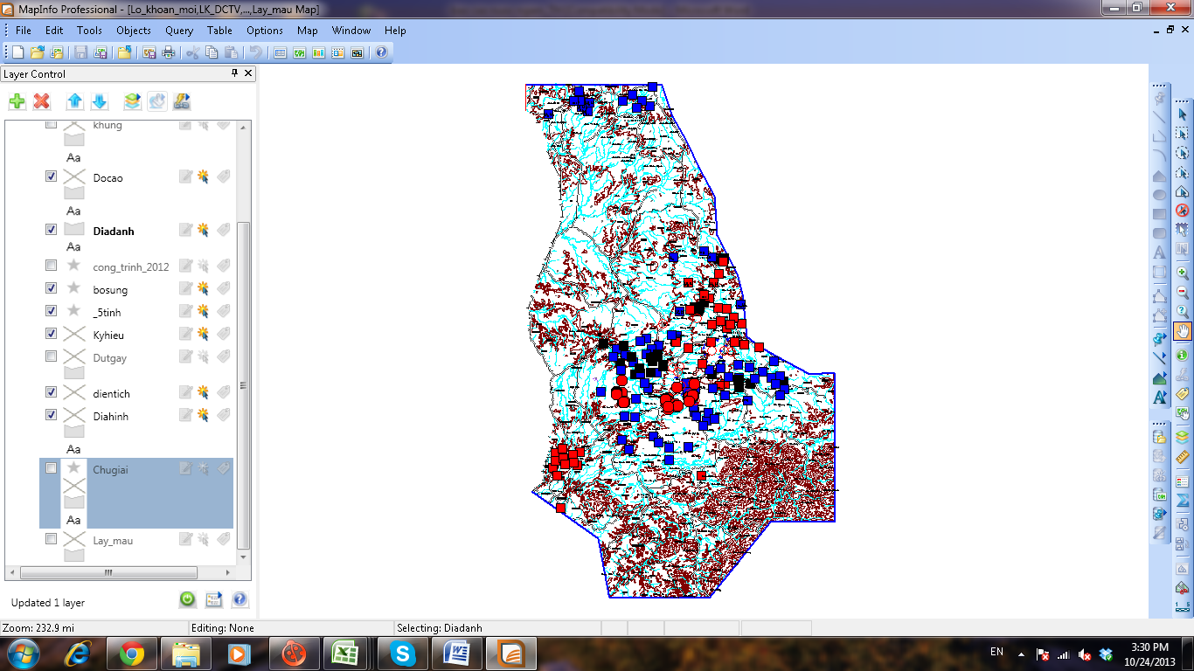 | 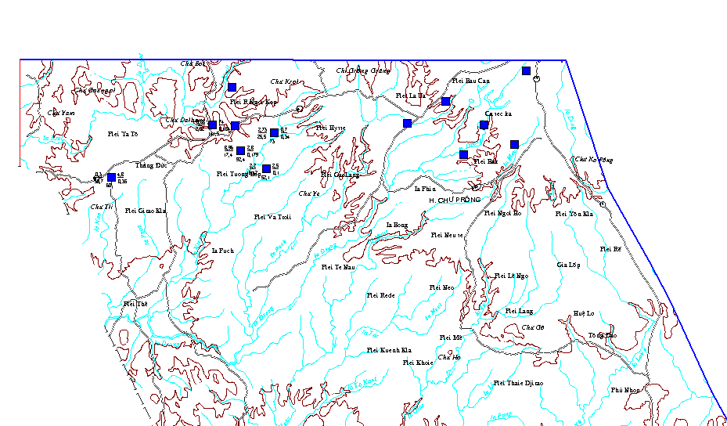  Diagram of discharge process during 1993-2012 at exposure point of DL11
Fig. 4: Water table process in Chu Prong district - Gia Lai province
In accordance with observation data of the dynamics of exposure point of DL11 (Chu Prong- Gia Lai), the discharge is reduced significantly with time. During 1993 - 1999 the discharge in DL11 during rainy season fluctuate within 45.0 to 62.0 l/s, however during 2000 so far, the fluctuation range is only 10.0 to 2.0 l/s (Fig. 4)

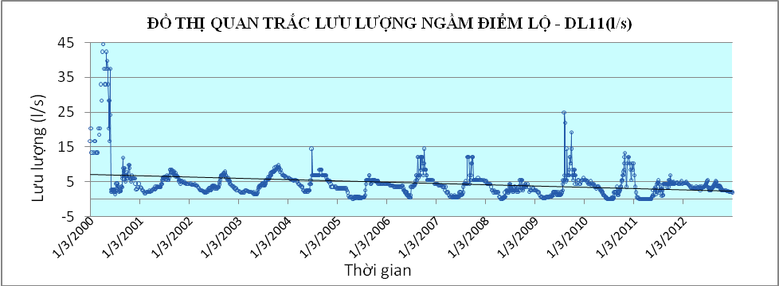
Fig 5: Discharge process with time during 2001-2012 at disposed point of DL11
Dak Lak province
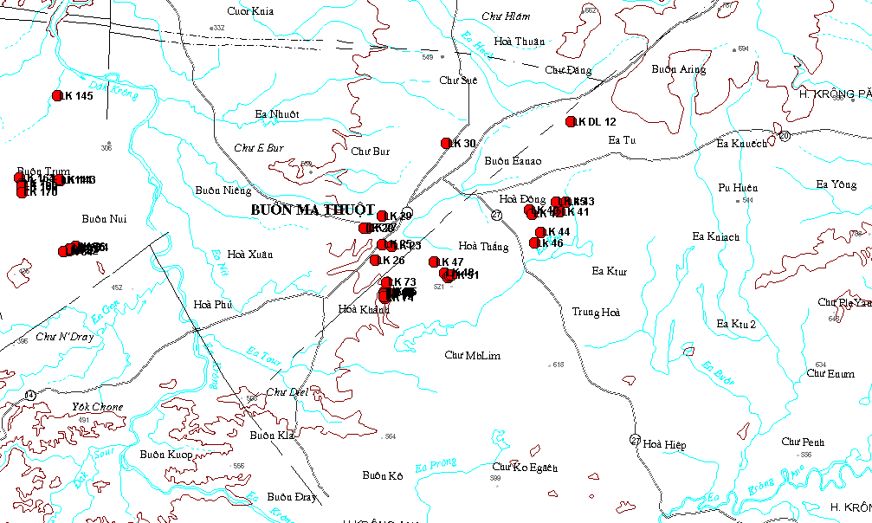
The insignificant change of groundwater level (water table) in the center of Buon Ma Thuot city in many observation data series from 2000 up to now.
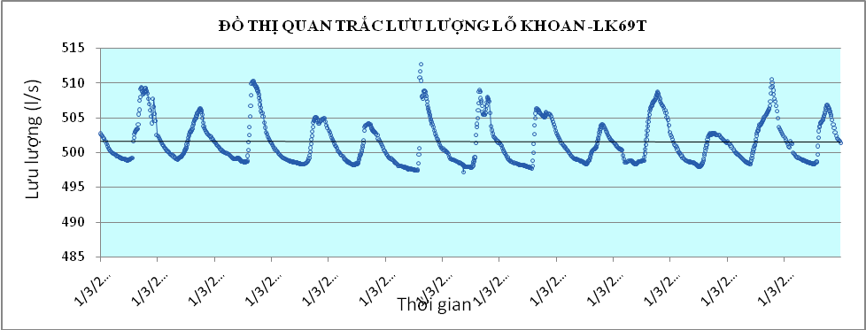  Fig 2: Diagram of water level – discharge fluctuation with time during 2000-2012 at LK 69T (Hoa Khanh – Dak Lak) | 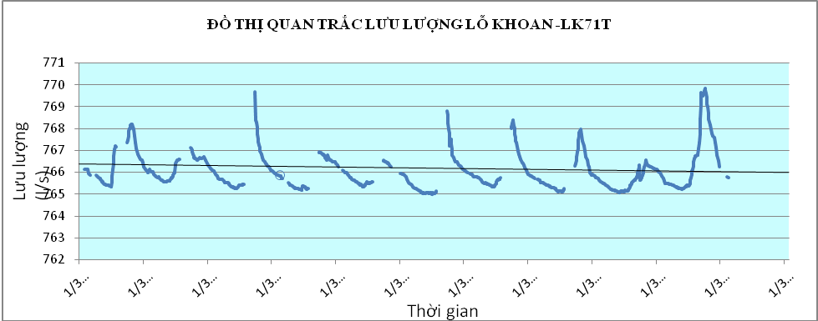  Fig 2: Diagram of water level – discharge fluctuation with time during 2000-2012 at LK 71T ( Hoa Khanh – Dak Lak)
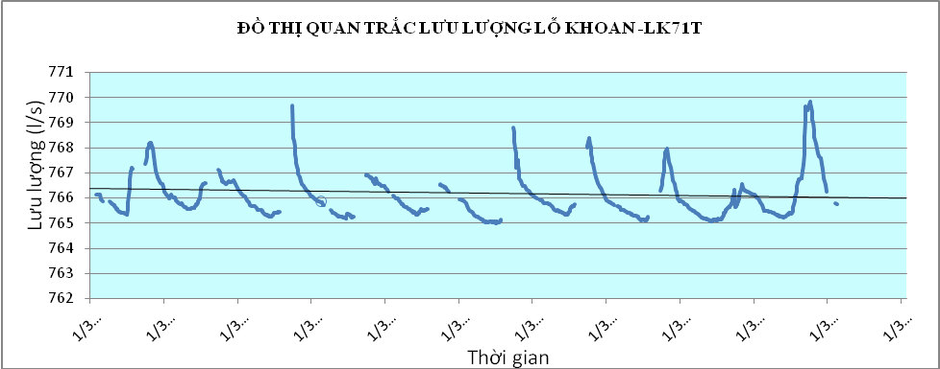
Fig 2: Diagram of water level – discharge fluctuation with time during 2000-2012 at LK 71T ( Hoa Khanh – Dak Lak)

Water table process in the East of Buon Ma Thuot city – Hoa Dong and Buon Eanao
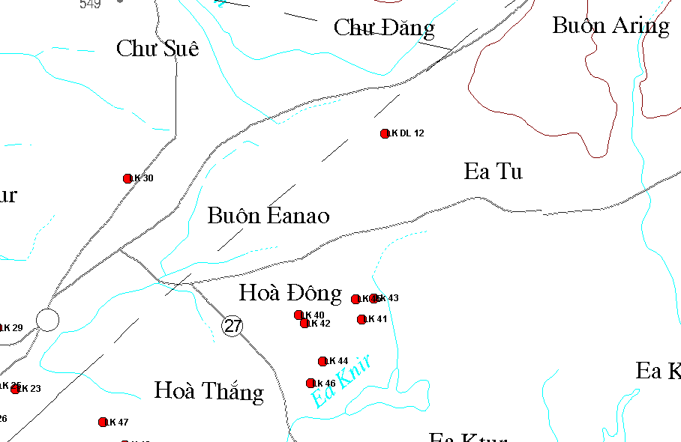 | Fig 2: Diagram of discharge fluctuation with time during at exposure point DL8 (Krong Pak – Dak Lak)
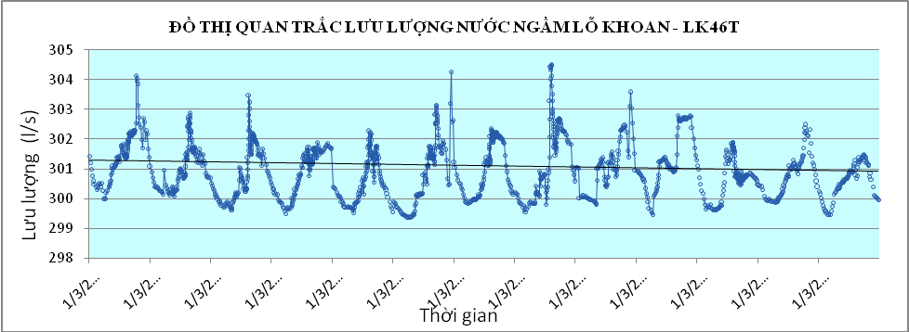
Fig 2: Diagram of water level – discharge fluctuation with time at drill hole of LK 46T
At exposure point of DL8 (Krong Pak – Dak Lak), it is found that during 1999 - 2004 the discharge during rainy season changes from 7.0 to 9.8 l/s, however since 2005 up to now this range is only 1.0 – 1.7 l/s (Fig 2).
Lowered water level in drill wells: similar to dynamics of exposure points of groundwater, water levels at some observation holes tend to reduce with time with the reduction rate of 1.0 to 4.0 m (Fig 3, Fig 4, Fig 5, Fig 6).

Fig 3: Diagram of water level fluctuation with time at observation drill hole of C8a (Ea Phe – Dak Lak)
Fig 4: Diagram of water level fluctuation with time at observation drill hole of 50T (Krong Pak – Dak Lak)

Fig 5: Diagram of water level fluctuation with time at observation drill hole of 30T (Ea H’Leo – Dak Lak)

Water table process in Dak Mil –Krong Kno, Dak Nong province
Fig 6: Diagram of water level fluctuation with time at observation drill hole of 41T (Dak Mil – Dak Nong).
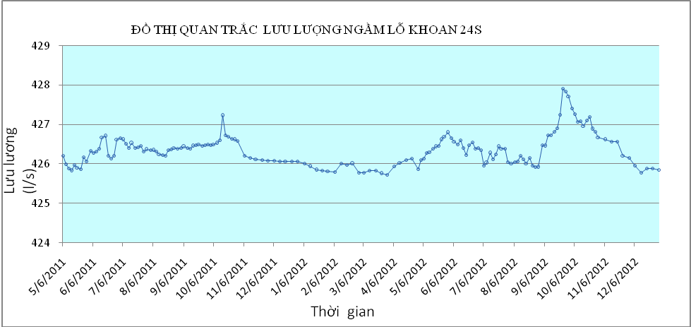
Fig 6: Diagram of water level – discharge fluctuation with time at observation drill hole of 24S ( Krong Kno - Dak Nong).
Especially, in dry season of 2013, many drill wells cannot be exploited due to significantly reduced water level. It is oblivious with water supply drill holes in Buon Ma Thuot city with only 30,000 m³ exploited per day, which is a reduction of 15,000 m³ per day compared to previous years. Many wards of Buon Ma Thuot city have been rotationally cut with water supply for every 2 days one work during last April and May. A series of dug well of local people is exhausted and cannot be exploited any more. At present, in many areas, water tables, especially in basalt aquifers have been significantly reduced where coffee trees are widespread grown.
In the past when the coffee planting area is still limited, the irrigation water is mainly from rivers and streams, springs and shallow drill wells. With the increasing demands, exposure sources have been exhausted, springs have been barred for pumping, i.e. several small dams barring a small spring every few kilometers, such as Ea Chu Kap, Ea Knir, Ea Dang etc. That is groundwater is exploited through dug and drill wells in a random manner. Most of dug wells provide enough water to irrigation activities. After sometime, the water table is reduced so local people have to dig as deep as 5 – 7m more to get water. As the water table is reduced, the shallow groundwater reserve is reduced accordingly. Horizontal and deeper drillings are some of ways to exploit groundwater for coffee irrigation. Especially, during the last dry season, the shortage of water has been urgently forecasted since the early season when most of wells cannot supply enough irrigation water or just enough during early times (January 2013). In general, the reduction of water table and groundwater reserve is obvious and prevailing in all basalt aquifers.
Exhaustion due to running out of water sources: in accordance with measurement and drawing result of hydrology and geological maps scaling 1:200,000, areas for exploration of Federation of Water Resource Planning and investigation of Central Region as above mentioned, many exposure underground sources have been detected. These are exposure underground sources in the shallow layer in basalt crust. Rule of these exposure sources depend on the separation of topography, i.e. the more strongly divided terrain topography will see more exposure sources; however capacity of these exposure sources is not abundant; small exposure sources are prevailing (discharge of 0.5 to 1.5 l/s) in Chu Prong (Gia Lai); Ea H’Leo, Krong Nang (Dak Lak); Dak Song, Dak Glong, Krong Kno (Dak Nong). In lightly divided terrain topographies, fewer exposure sources are encountered, yet the capacity is larger. Especially there is a group of exposure sources having discharge of tens of liters per second such as exposure source group No.4 (Phuoc An) have capacity of 80.62 l/s; exposure source group No. 3 (Co Tam) have capacity of Q_{Min}= 50 l/s; exposure source group No… (Buon Hồ) with 25.6 l/s.

5.2 Case study of interaction between surface water resource and groundwater in basalt area of Buon Ma Thuot.
MIKE SHE model is an integrated model of advanced hydrology. The model simulates the flow in the entire period based on hydrological cycle (river runoff), through different types of flows such as runoff, water penetrates into the ground, evaporation from flora, and ground flow.
Through the analysis of project conditions, collected data and based on the simulation of MIKE SHE, and due to limited study time, we cannot develop a data applied to the eintre Serepok river basin .
In order to consider the impact of the surface water exploitation system in the project on groundwater exploitation, we suggest the calculation for Ea Tul river basin in Serepok river basin.
Components to be simulated in the calculation model include:
- Flow components in rivers (one way flow river network).
- Flow component as surface run-off (two way flow).
- Underground runoff includes upper and lower non-saturation flows.
- Water exploitation and exchange components between plantation coverage and remaining components supplying water for the surface evaporation process.
Evapo-ration
Surface overflow-ing
SURFACE
Saturated underground flow
Unsaturated underground flow
In open canal
SUBTERRANEAN
Fig…. Structure of MIKE SHE mathematical model for basalt area in Buon Ma Thuot highlands
Scope of studying
The case study area is located on the right bank of Krong Ana river and mainstream of Srepok river with a catchment of 2,380 km² including lands of Buon Don, C’MGar, KrongBuk, KrongPac district, Buon Ma Thuot city, Krong Bong, Krong Ana districts.
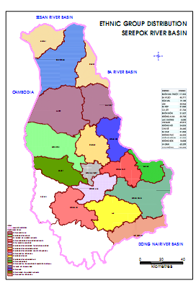 | 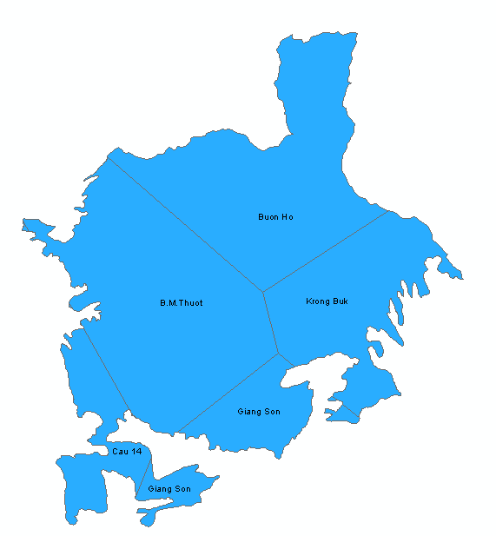
Requirement of input data for the establishment of MIKE SHE mathematical model.

5.2.1. Components of surface flow
The project area has a topography which is lowered gradually in northeast – Southwest direction from elevation of 600-800m to 200-300m.

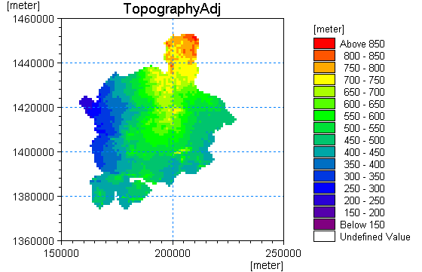
Fig: Topography map of the studied area
The river and stream network in the project area has 42 tributaries which are all included in the calculation which are distrusted in relatively even manner in the entire project area.
The channel of rivers in the project area is identified based on the combination of topography map (DEM) of the project area in reference with and comparison with available river network map.
River network simulating surface runoff:
No. | River | River length  (Km) | Running into river (name of river) | Location
1 | R22 | 10.0 | R20 | 14.0
2 | R21 | 16.0 | R20 | 23.1
3 | Ea Moll | 10.8 | R10 | 18.0
4 | Ea Ho | 5.4 | Krong Buk | 28.6
5 | KBtributary7 | 6.8 | Krong Buk | 17.4
6 | Ea Dey | 4.2 | Krong Buk | 19.4
7 | Ea Jung | 7.6 | Krong Buk | 39.0
8 | Ea Hlang | 13.3 | Krong Buk | 46.0
9 | Ea Su | 13.9 | Krong Buk | 65.3
10 | Ea Kmlir | 13.2 | Krong Buk | 55.0
11 | Ea Kung | 11.7 | Krong Buk | 59.0
12 | Ea Blang | 9.2 | Krong Buk | 47.0
13 | Ea Buk | 1.8 | Krong Buk | 11.0
14 | Ea Adrant | 16.4 | Ea Tul | 30.6
15 | Ea Dong | 8.8 | Ea Tul | 23.2
16 | Ea Hpreah | 14.8 | Ea Tul | 42.5
17 | Ea Chur | 32.5 | Ea Tul | 50.1
18 | Ea Klih | 10.4 | Ea Tul | 41.5
19 | Ea Sen | 6.9 | Ea Puor | 9.9
20 | Ea Nieah | 22.4 | Ea Noec | 20.1
21 | Ea Muich | 23.0 | Ea Kung | 10.0
22 | Ea Hue | 9.3 | Ea Kuang | 13.4
23 | Ea Tam | 17.3 | Ea Knir | 30.0
24 | Ea Mdha | 8.7 | Ea Kmur | 13.5
25 | Ea Kpal | 14.0 | Ea Klih | 8.5
26 | Ea Pe | 7.0 | Ea Jung | 4.7
27 | Ea Bar | 11.8 | Ea Chur | 25.0
28 | Ea Kar | 12.6
29 | Krong Buk | 70.5
30 | Ea Kuang | 27.0
31 | Ea Uy | 10.4
32 | Ea Phe | 23.2
33 | Ea Puor | 26.0
34 | Ea Noec | 27.6
35 | Ea Anut | 20.4
36 | Ea Kao | 18.4
37 | Ea Knir | 44.5
38 | Ea Nhiol | 17.2
39 | Ea Kmur | 20.3
40 | Ea Tul | 64.0
41 | R10 (EA Ram) | 22.3
42 | R20 (Dak M Roh) | 53.4
Summary of data on existing structures in the project area:
- 11 large scale structure having total useful capacity of 73 million m³.
- 18 medium scale structure having total useful capacity of 10,98 million m³
Table: Large scale hydraulic works in the region

No. | Structure | Streams | Commune | District | Catchment area (Flv)  (km² ) | Whi  (10³m³)
1 | Ea Kar | Ea Kar | C Ni | Ea Kar | 26.9 | 10 500
2 | Krong Buk hạ | Krong Buk | Ea Phe | Krong Pak | 295 | 2 900
3 | Ea Kuang | Ea Kuang | Ea Yong | Krong Pak | 6.5 | 5 000
4 | Ea Nhai I | Ea Niaeh | Hoa Dong | Krong Pak | 3 | 10 500
5 | Ea Uy | Ea Wy | Hoa Tien | Krong Pak | 28 | 6 300
6 | Drao I | Ea Bru | C Dlie Mnong | C Mgar | 6.2 | 2 204
7 | Drao II | Ea Bru | C Dlie Mnong | C Mgar |  | 3 300
8 | Ea Bih | khe nhỏ | Ea Bhok | Krong Ana | 5.0 | 1 280
9 | Ea Hning | Ea Puor | Ea Ktur | Krong Ana | 8.3 | 2 200
10 | Ea Kao | Ea Kao | Ea Kao | Buon Ma thuot | 104 | 17 763
11 | Ea Chur Kap | Ea Chur Kap | Hoa Thang | Buon Ma thuot | 15 | 11 200

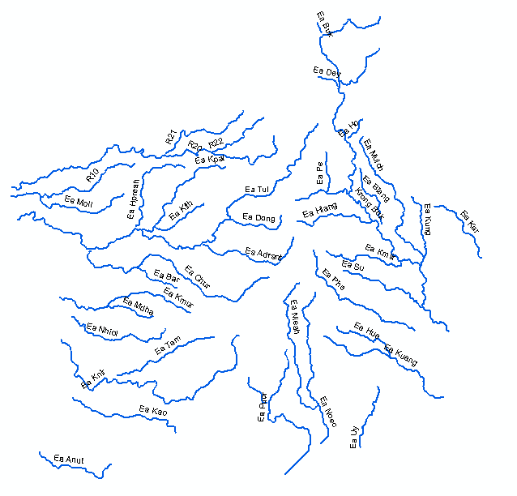
Fig. River network included in the calculation model

5.2.2 Components of groundwater flow
Penetration flow from surface or rivers will create flows in aquifers. There are two types of flows in saturated and unsaturated soil layers and saturated layer is the lower one.

In accordance with survey and exploration data of groundwater evaluation of Central Region and Central Highland Geological Federation and according to field survey of the project (April 2013), there is big change in the depth of aquifers, either in terms of topographical surface and position of the aquifer. The change of depth is from 4 to 30 m in Buon Ma Thuot.
Table 3.7. Data o geological drill holes and groundwater drill wells in Srepok river basin
No. | Code of drill wells on exploitation | Commune | District | X, | Y, | Depth LK, m | Aquifer | Exploited discharge, m³/day
1 | LK12 | Thang Loi Coffee Company | KrongPach | 1403578 | 193493 | 65 | Basalt | 193.5
2 | Lk 15 | People’s Committee of EaKNuech commune | KrongPach | 1406399 | 196695 | 90 | Basalt | 108.9
3 | LK 14 | Thang Loi Coffee Company | KrongPach | 1403635 | 195994 | 65 | Basalt | 229.8
4 | LK 13 | Thang Loi Coffee Company | KrongPach | 1402381 | 193659 | 70 | Basalt | 211.7
5 | LK 350 | Thang Loi | KrongPach | 1403606 | 194590 | 80 | Basalt | 467
6 | LK 352 | Thang Loi | KrongPach | 1403882 | 194886 | 80 | Basalt | 566
7 | LK 353 | Thang Loi | KrongPach | 1402973 | 193925 | 80 | Basalt | 503
8 | LK 355 | Thang Loi | KrongPach | 1402725 | 193545 | 90 | Basalt | 211
9 | LK 379 | Ea Kenh | KrongPach | 1407320 | 199892 | 70 | Basalt | 108
10 | LK 380 | Hoa Dong | KrongPach | 1405605 | 192446 | 80 | Basalt | 217
11 | LK 381 | Ea Kenh | KrongPach | 1405605 | 200099 | 60 | Basalt | 78
12 | LK 382 | Hoa Dong | KrongPach | 1405679 | 192001 | 80 | Basalt | 144
13 | LK 384 | Tan Tien | KrongPach | 1398979 | 211262 | 60 | Basalt | 114
14 | LK 386 | Hoa An | KrongPach | 1407489 | 209975 | 60 | Basalt | 96
15 | LK 387 | EaPhe | KrongPach | 1408052 | 212927 | 65 | Basalt | 138
16 | LK 388 | Ea Phe | KrongPach | 1408516 | 213582 | 65 | Basalt | 126
17 | LK 389 | Ea Phe | KrongPach | 1408808 | 213782 | 60 | Basalt | 48
18 | LK 390 | Ea Phe | KrongPach | 1409634 | 213208 | 65 | Basalt | 138
19 | LK 391 | Ea Phe | KrongPach | 1409411 | 214329 | 60 | Basalt | 288
20 | LK 392 | Ea Phe | KrongPach | 1412820 | 214374 | 45 | Basalt | 36
21 | LK 393 | Ea Phe | KrongPach | 1408562 | 214078 | 65 | Basalt | 78
22 | Lk 21 | Stadium | B.M.Thuot | 1403403 | 178701 | 100 | Basalt | 24
23 | Lk 22 | Medical vocational school | B.M.Thuot | 1402857 | 178172 | 100 | Basalt | 12
24 | LK 23 | Teacher Training College | B.M.Thuot | 1401205 | 177900 | 120 | Jurra | 234
25 | LK 27 | General depot Mai Hac De1 | B.M.Thuot | 1402326 | 176501 | 93 | Basalt | 59
26 | LK 28 | General depot Mai Hac De2 | B.M.Thuot | 1402305 | 176252 | 100 | Basalt | 90
27 | LK 30 | Mr. Nhị’s | B.M.Thuot | 1407246 | 181295 | 115 | Basalt | 77
28 | LK 35 | Mr. Thỉnh’s | B.M.Thuot | 1407158 | 184406 | 60 | Basalt | 163
29 | LK 39 | Ea Sup | B.M.Thuot | 1402556 | 184597 | 80 | Basalt | 181
30 | LK 40 | Kindergarten of Ea Kmat | B.M.Thuot | 1403155 | 186175 | 80 | Basalt | 193
31 | LK 42 | EaKMat residential quarter | B.M.Thuot | 1402915 | 186337 | 70 | Basalt | 163
32 | Lk 43 | Ea Kmat nursery garden | B.M.Thuot | 1403602 | 188359 | 70 | Basalt | 181
33 | LK 45 | EaKmat coffee experimental area | B.M.Thuot | 1403595 | 187821 | 70 | Basalt | 181
34 | LK 50 | HDRat fields | B.M.Thuot | 1399382 | 181112 | 38 | Basalt | 97
35 | LK 47 | Ea Tam husbandry farm | B.M.Thuot | 1400180 | 180418 | 80 | Basalt | 102
36 | LK 48 | Ea Tam chicken farm | B.M.Thuot | 1399503 | 181036 | 120 | Basalt | 133
37 | LK 49 | Ea Kao State coffee farm | B.M.Thuot | 1399224 | 181204 | 70 | Basalt | 120
38 | LK 51 | Hoa Thang | B.M.Thuot | 1399345 | 181338 | 80 | Basalt | 157
39 | LK 52 | Hoa Thang | B.M.Thuot | 1399378 | 181464 | 90 | Basalt | 36
40 | LK 54 | Hoa Thang | B.M.Thuot | 1399529 | 181519 | 90 | Basalt | 302
41 | LK 57 | Hoa Binh Company | B.M.Thuot | 1399455 | 177351 | 70 | Basalt | 90
42 | LK 61 | EaKao | B.M.Thuot | 1397979 | 177494 | 40 | Basalt | 72
43 | LK 16 | Bạch Mã hotel | B.M.Thuot | 1404039 | 178971 | 80 | Basalt | 48.4
44 | LK HT10 | Hoa Thang | B.M.Thuot | 1400822 | 187978 | 80 | Basalt | 864
45 | LK 194 | Hoa thuan | B.M.Thuot | 1407954 | 188331 | 80 | Basalt | 1555.2
46 | LK 239 | Radio station | B.M.Thuot | 1403018 | 178892 | 80 | Basalt | 42
47 | LK 243 | Village 1 - Ea Cao | B.M.Thuot | 1397476 | 177290 | 40 | Basalt | 78
48 | LK 245 | We Village- Ea Cao | B.M.Thuot | 1397616 | 178863 | 70 | Basalt | 157
49 | LK 246 | We Village- Ea Cao | B.M.Thuot | 1397525 | 179413 | 70 | Basalt | 181
50 | LK 247 | We Village- Ea Cao | B.M.Thuot | 1397887 | 179595 | 80 | Jurra | 193
51 | LK 248 | We Village- Ea Cao | B.M.Thuot | 1397900 | 179540 | 60 | Basalt | 205
52 | LK 249 | We Village- Ea Cao | B.M.Thuot | 1397904 | 179691 | 50 | Basalt | 187
53 | LK 250 | We Village- Ea Cao | B.M.Thuot | 1397948 | 179748 | 50 | Basalt | 175
54 | LK 252 | We Village- Ea Cao | B.M.Thuot | 1397931 | 179249 | 56 | Basalt | 187
55 | LK 253 | We Village- Ea Cao | B.M.Thuot | 1397990 | 179597 | 55 | Basalt | 217
56 | LK 255 | We Village- Ea Cao | B.M.Thuot | 1397951 | 179510 | 52 | Basalt | 169
57 | LK 256 | We Village- Ea Cao | B.M.Thuot | 1397929 | 179451 | 45 | Basalt | 139
58 | LK DL 2 | Hoa Thuan | B.M.Thuot | 1407490 | 187999 | 93 | Basalt | 639
59 | LK DL 3 | Hoa Thuan | B.M.Thuot | 1407949 | 187334 | 80 | Basalt | 205
60 | LK DL 5 | Hoa Thuan | B.M.Thuot | 1408973 | 187861 | 81.5 | Basalt | 1918
61 | LK DL 14 | Hoa Thuan | B.M.Thuot | 1408076 | 188092 | 80 | Basalt | 864
62 | LK HT 1 | Hoa Thang | B.M.Thuot | 1400816 | 187463 | 82.5 | Basalt | 90
63 | LK HT 10 | Hoa Thang | B.M.Thuot | 1400816 | 187472 | 79 | Basalt | 108
64 | LK HT 2 | Hoa Thang | B.M.Thuot | 1400127 | 186824 | 81.4 | Basalt | 316
65 | LK HT 3 | Hoa Thang | B.M.Thuot | 1401036 | 187994 | 82 | Basalt | 950
66 | LK HT 5 | Hoa Thang | B.M.Thuot | 1400016 | 187183 | 75 | Basalt | 172
67 | LK 271 | Buon Hue - Ea Cao | B.M.Thuot | 1398056 | 181420 | 70 | B+Jura | 48
68 | LK 272 | Ea Cao State Enterprise | B.M.Thuot | 1398565 | 178823 | 55 | Basalt | 193
69 | LK 280 | Village 1 - Ea Cao | B.M.Thuot | 1396250 | 178132 | 26 | Basalt | 48
70 | LK 281 | Village 1 - Ea Cao | B.M.Thuot | 1396241 | 178157 | 28 | Basalt | 36
71 | LK 282 | Village 1 - Ea Cao | B.M.Thuot | 1396237 | 178202 | 26 | Basalt | 30
72 | LK 283 | Village 1 - Ea Cao | B.M.Thuot | 1396232 | 178202 | 28 | Basalt | 24
73 | LK 284 | Village 1 - Ea Cao | B.M.Thuot | 1396025 | 178212 | 26 | Basalt | 36
74 | LK 285 | Village 1 - Ea Cao | B.M.Thuot | 1396171 | 178169 | 26 | Basalt | 24
75 | LK 286 | Village 1 - Ea Cao | B.M.Thuot | 1396171 | 178185 | 26 | Basalt | 36
76 | LK 287 | Village 1 - Ea Cao | B.M.Thuot | 1396321 | 178055 | 27 | Basalt | 30
77 | LK 288 | Village 1 - Ea Cao | B.M.Thuot | 1396305 | 178074 | 25 | Basalt | 30
78 | LK 289 | Village 1 - Ea Cao | B.M.Thuot | 1396341 | 178045 | 26 | Basalt | 24
79 | LK 290 | Village 1 - Ea Cao | B.M.Thuot | 1396315 | 178092 | 24 | Basalt | 24
80 | LK 291 | Village 1 - Ea Cao | B.M.Thuot | 1396334 | 178064 | 25 | Basalt | 24
81 | LK 292 | Village 1 - Ea Cao | B.M.Thuot | 1396142 | 178309 | 26 | Basalt | 24
82 | LK 293 | Village 1 - Ea Cao | B.M.Thuot | 1396050 | 178344 | 26 | Basalt | 36
83 | LK 294 | Village 1 - Ea Cao | B.M.Thuot | 1396106 | 178377 | 26 | Basalt | 30
84 | LK 295 | Village 1 - Ea Cao | B.M.Thuot | 1396017 | 178292 | 28 | Basalt | 36
85 | LK 296 | Village 1 - Ea Cao | B.M.Thuot | 1396017 | 178284 | 28 | Basalt | 30
86 | LK 297 | Village 1 - Ea Cao | B.M.Thuot | 1395995 | 178251 | 26 | Basalt | 24
87 | LK 298 | Village 1 - Ea Cao | B.M.Thuot | 1395972 | 178205 | 25 | Basalt | 36
88 | LK 299 | Village 1 - Ea Cao | B.M.Thuot | 1395965 | 178192 | 29 | Basalt | 36
89 | LK 300 | Village 1 - Ea Cao | B.M.Thuot | 1396299 | 178100 | 22 | Basalt | 24
90 | LK 301 | Village 1 - Ea Cao | B.M.Thuot | 1396192 | 178136 | 30 | Basalt | 36
91 | LK 302 | Village 1 - Ea Cao | B.M.Thuot | 1396181 | 178145 | 30 | Basalt | 36
92 | LK 323 | EaNuol | Buon Don | 1408357 | 819489 | 50 | B+Jura | 114
93 | LK 328 | EaWew | Buon Don | 1418596 | 813874 | 45 | B+Jura | 72
94 | LK. QK5-2 | Ha Lan pass | KrongBuk | 1418633 | 200280 | 156 | Basalt | 72
95 | LK. QK5-3 | Ha Lan pass | KrongBuk | 1418366 | 201721 | 120 | Basalt | 266
96 | LK 363 | PơngDRang | KrongBuk | 1434269 | 201037 | 97 | Basalt | 102
97 | LK 364 | PơngDRang | KrongBuk | 1433959 | 200953 | 80 | Basalt | 96
98 | LK 365 | Thong nhat | KrongBuk | 1431116 | 202919 | 70 | Basalt | 145
99 | LK 260 | Việt Duc 6 - Ea Tieu | KrongAna | 1394030 | 181584 | 50 | Basalt | 163
100 | LK 373 | Ea Na | KrongAna | 1387516 | 173760 | 80 | Basalt | 139
101 | LK 375 | Ea Na | KrongAna | 1387373 | 825417 | 85 | Basalt | 157
102 | LK 376 | Ea Na | KrongAna | 1386533 | 173900 | 80 | Basalt | 132
103 | LK 377 | Buon Trap town | KrongAna | 1381111 | 177678 | 65 | Basalt | 108
104 | LK 378 | Buon Trap town | KrongAna | 1381436 | 177502 | 75 | B+Jura | 126
105 | LK 355 | EaKhal | EaHleo | 1457436 | 191725 | 70 | Basalt | 78

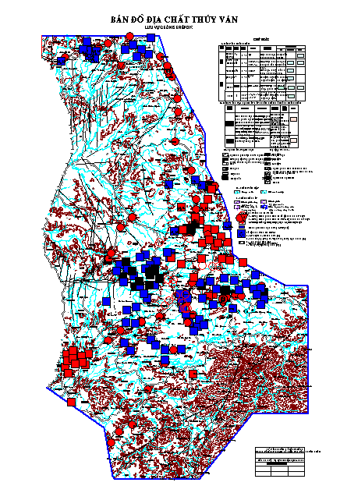
Fig: Geological and hydrological map of the study area

5.2.3 Land exploitation and unitization
Exploitation of surface water and groundwater for agriculture production is a predominant practice in the project area. The mathematic model is used in the project to calculate in quantitative manner impacts of three land use distribution options corresponding to different deadlines (water use options).
- Water use option in 2005
- Water use option in 2010
- Water use option in 2020
For water use options in 2005, we have following calculation inputs:
- Land use data in 2005
- Data on land use and exploitation works in 2005
- Hydrology and meteorology data in 2005
- Water supply option in 2005
Similarly to cases of 2010 and 2020.
Land use planning documents of Agriculture Planning and Projection Institute, Dak Lak Department of Agriculture and Rural Development

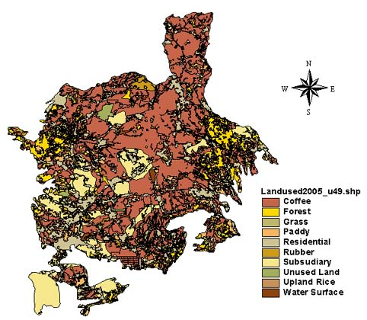
Fig 1. Land use map in 2005

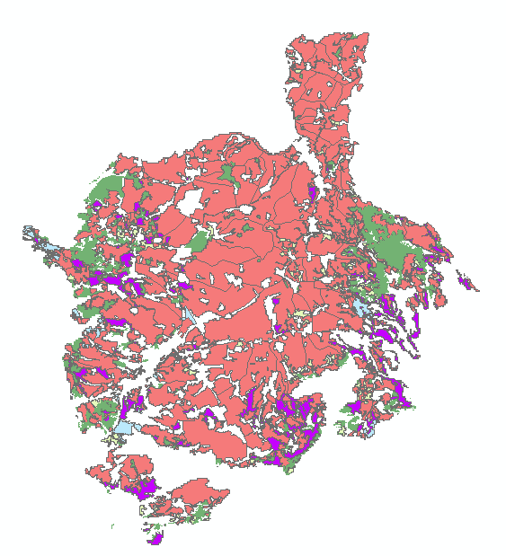 | 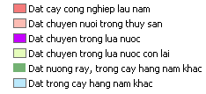
Fig 2. Land use map in 2010

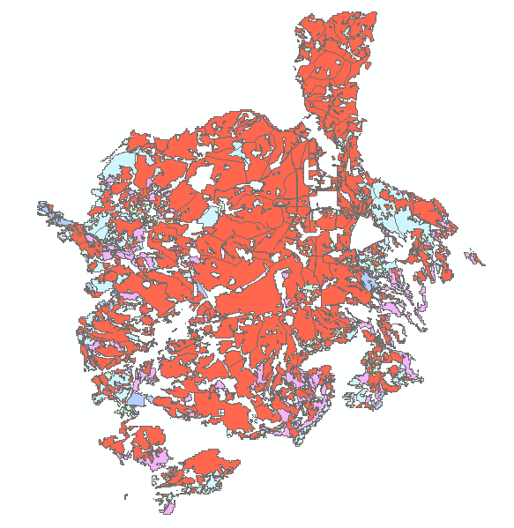 | 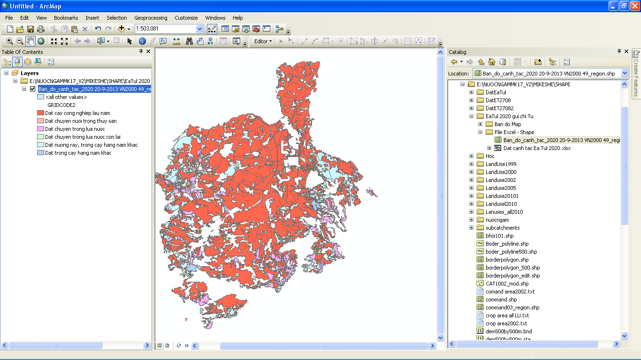
Fig 3. Land use map in 2020

Table 3.8. Parameters of main crops in the project area
No. | Types of crops /  Parameters | Initial period | Growth period | Intermediary period | Final period | Total time (days) | Starting date
1 | Winter-spring rice |  |  |  |  |  | 25/12–20/1
1 | Number of days (day) | 25 | 30 | 40 | 25 | 120
1 | Kc (-) | 1.05 | 1.10 | 1.20 | 0.9
1 | LAI (m2/m2) | 2.5 | 4.5 | 4.5 | 4.5
1 | RZ (mm) | 500 | 650 | 850 | 1000
2 | Summer-autumn rice |  |  |  |  |  | 15/5-10/6
2 | Number of days (day) | 20 | 30 | 35 | 25 | 110
2 | Kc (-) | 1.1 | 1.15 | 1.3 | 1.0
2 | LAI (m2/m2) | 2.5 | 4.5 | 4.5 | 4.5
2 | RZ (mm) | 500 | 650 | 850 | 1000
3 | Terraced rice |  |  |  |  |  | 25/5-6/6
3 | Number of days (day) | 20 | 30 | 30 | 25 | 105
3 | Kc (-) | 1.05 | 1.10 | 1.20 | 0.95
3 | LAI (m2/m2) | 2.0 | 2.5 | 3.0 | 3.0
3 | RZ (mm) | 500 | 650 | 800 | 1000
4 | Winter-spring maize |  |  |  |  |  | 10/12-25/12
4 | Number of days (day) | 15 | 30 | 30 | 20 | 95
4 | Kc (-) | 0.6 | 0.9 | 1.15 | 0.8
4 | LAI (m2/m2) | 1.5 | 3 | 3 | 2.5
4 | RZ (mm) | 300 | 800 | 1200 | 1200
5 | Summer-autumn maize |  |  |  |  |  | 29/4-15/5
5 | Number of days (day) | 15 | 30 | 30 | 20 | 95
5 | Kc (-) | 0.6 | 0.9 | 1.15 | 0.8
5 | LAI (m2/m2) | 1.5 | 3 | 3 | 2.5
5 | RZ (mm) | 300 | 800 | 1200 | 1200
6 | Coffee (1st year ) |  |  |  |  |  | 1/6-11/6
6 | Number of days (day) | 90 | 90 | 90 | 95 | 365
6 | Kc (-) | 0.9 | 0.92 | 0.95 | 0.95
6 | LAI (m2/m2) | 6 | 6.0 | 6.5 | 6.5
6 | RZ (mm) | 1000 | 1400 | 1800 | 1800
7 | Coffee
7 | Number of days (day) | 90 | 90 | 90 | 95 | 365
7 | Kc (-) | 0.95 | 0.95 | 0.95 | 0.95
7 | LAI (m2/m2) | 6.5 | 6.5 | 6.5 | 6.5
7 | RZ (mm) | 1800 | 1800 | 1800 | 1800
8 | Rubber (1st year )
8 | Number of days (day) | 90 | 90 | 90 | 95 | 365
8 | Kc (-) | 0.95 | 0.97 | 1 | 1
8 | LAI (m2/m2) | 5 | 6 | 7 | 7
8 | RZ (mm) | 900 | 1100 | 1300 | 1500
9 | Rubber
9 | Number of days (day) | 90 | 90 | 90 | 95 | 365
9 | Kc (-) | 1 | 1 | 1 | 1
9 | LAI (m2/m2) | 7 | 7 | 7 | 7
9 | RZ (mm) | 1500 | 1500 | 1500 | 1500
10 | Pepper
10 | Number of days (day) | 90 | 90 | 90 | 95 | 365
10 | Kc (-) | 0.95 | 0.97 | 1 | 1
10 | LAI (m2/m2) | 2 | 3 | 3.5 | 3.5
10 | RZ (mm) | 900 | 1100 | 1300 | 1500
11 | New cultivation area
11 | Number of days (day) | 90 | 90 | 90 | 95 | 365
11 | Kc (-) | 0.5 | 0.8 | 0.95 | 0.7
11 | LAI (m2/m2) | 3.5 | 3.5 | 3.5 | 3.5
11 | RZ (mm) | 500 | 800 | 1000 | 1200
- Establishment of surface water exploitation system in 2005
In accordance with surveyed and collected data in 2005, there are 243 structures in the river basin exploiting surface water with total irrigation area of: coffee 26,304 ha and wet paddy: 6,602 ha. The study team included in the mathematical model the summary of 53 structures include single large scale works as Krong Buk hạ, Buon Trinh and Ea Nhai.
The location and area maps of 53 irrigation areas in 2005 were developed based on the land use map in 2005 and collected data on status of hydraulic works 2005.
- Establishment of surface water exploitation system in 2010
In accordance with survey report in 2010, there are 274 large, medium and small scale water supply structures providing irrigation water to 20,297ha of wet paddy, 22,657ha of annual crops, 139,146 ha of annual cash trees.
The location and area maps of 289 irrigation areas in 2010 were developed based on the land use map in 2010 and collected data on status of hydraulic works 2010 .
- Establishment of surface water exploitation system in 2020
In accordance with Planning report for 2020, the project area will see the projected construction of ………hydraulic works of large, medium and small scales providing irrigation water to 20,297ha of wet paddy, 22,657ha of annual crops, 139,146 ha of annual cash trees
The location and area maps of 276 irrigation areas in 2020 were developed based on the land use map in 2020 and oriented data on hydraulic works 2020.

Table ... Data relating to hydraulic works in different impact simulation options
No. | Data of land use maps | Number of actual works | Works included in the modeling | Area of surface irrigation (ha) | Irrigation area of coffee (ha) | Irrigation area of annual crops (ha)
1 | 2005 | 243 | 53 | 6.602 | 109.957 | 45.541
2 | 2010 | 274 | 69 | 20.297 | 139.146 | 22.657
3 | 2020 | 280 | 76 | 19.265 | 132.861 | 21.210

5.2.4. Calibration results of parameter sets of mathematical model– groundwater level (water tables) (m)
Simulation results of surface water modeling calibration
Fig 3.22. Calibration results of parameter sets of mathematical model– flow discharge at Krong Buk station (m3/s)
Fig 3.23. Calibration results of parameter sets of mathematical model– flow discharge on Ea Tul branch (m3/s)

5.2.5. Quantitative and calculation results of processes of key components
Impacts are identified through balance calculation of flow components in accordance with different options for 2005, 2010 and orientation for 2020. Serving for the objective of water balance calculation of flow components, there are two types of diagrams:
- A diagram including two components (i) surface flow component, (ii) combined component of subterraneous flows
- A diagram including main components: surface flow component and flow component of each subterraneous flow stratums.
The water balance diagram is presented in below chart:
Separation of components in the water balance diagram in MIKE SHE model (case of separating surface layer flow and integration of subterranean flows) - 2005 | Separation of components in the water balance diagram in MIKE SHE model (case of separating surface layer flow and subterranean flow layers) - 2005
 | 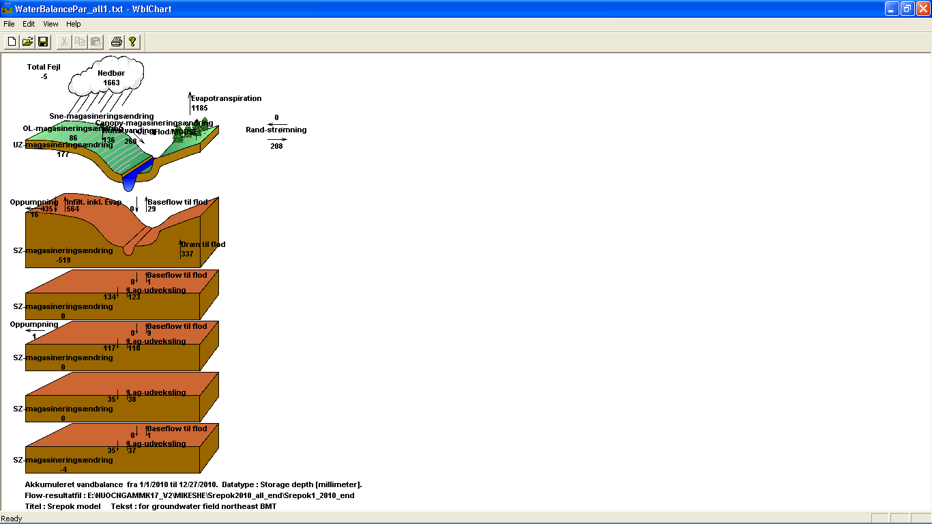
Separation of components in the water balance diagram in MIKE SHE model (case of separating surface layer flow and integration of subterranean flows) - 2010 | Separation of components in the water balance diagram in MIKE SHE model (case of separating surface layer flow and subterranean flow layers) - 2010
Separation of components in the water balance diagram in MIKE SHE model (case of separating surface layer flow and integration of subterranean flows) - 2020 | Separation of components in the water balance diagram in MIKE SHE model (case of separating surface layer flow and subterranean flow layers) - 2020
Based on the calculation result in the entire project, the study team has identified changes of different flow components of the integrated system and it is found that total evaporation from surface of the basin in 2010 makes up 71.5% which is higher than 2005 which was from 61.9% - 68.3% of total rainfall.
In 2005, total precipitation in the project area is 1,710mm in equivalent of 4,052 billion m³ of water including 60-70% as evaporation from cultivation areas and 30-40% as irrigation water penetrating into subsoils and running out of the basin.
In 2010, total precipitation in the project area is 1,663mm in equivalent of 3,957 billion m³ of water including 71% as evaporation from cultivation areas and 29% as irrigation water penetrating into subsoils and running out of the basin.
From the calculation results, it is found that the reduction of water table in 2010 in comparison with 2005 is quite great in Buon Ma Thuot city, i.e. 0-5m at almost all exploitation drill holes in the South and North; however the water table in the center of the study area remains unchanged.

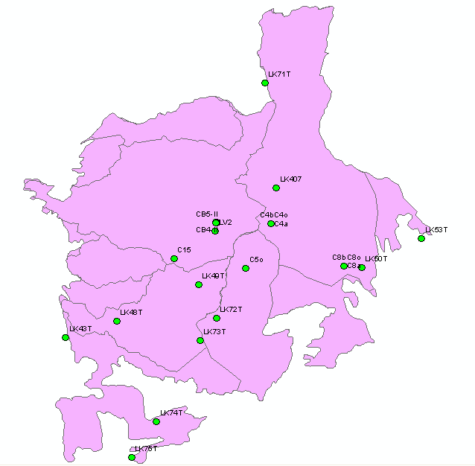
Comments
- Water tables change irregularly, i.e. not in accordance with any rule, and vary significantly in different regions in the studied area.
- Water tables reduced significantly in the North and the South whereas water tables in the central area and in the West have stable trend.
The reasons can be explained by the different cropping structures in 2005 and 2010 and simultaneous exploitation of groundwater for irrigation of cash trees. At the same time, the aquifers are also supplemented with surface water and highly located aquifers, leading to irregular fluctuation of water tables.
Table 4.3. Results of average annual water balance calculation (Unit: mm/year)
 | 1 | 2 | 3 | 4 | 5 | 6 | 7 | 8 | 9 | 10 | 11
Year of calculation | Precipitation | Changes of water storage in leaf canopy | Evaporation | Changes of water storage in ice and snow | Changes of water storage in surface | Surface inflow | Surface outflow | Surface loss | Overflows into river | Irrigation | Changes of water storage in near-surface
2005 | -1710 | 0.0 | 1068.3 | 0.0 | 2.2 | -69.9 | 163.1 | 0.0 | 246.7 | -58.4 | 15.2
2010 | -1663 | 0.0 | 1185.0 | 0.0 | 86 | -136 | 208.0 | 0.0 | 268.0 | -136 | 117
2020
 | 12 | 13 | 14 | 15 | 16 | 17 | 18 | 19 | 20 | 21 | 22
Year of calculation | Near-surface inflow | Near-surface outflow | Near-Surface loss | Pumping | Drained into river | Drained out into river | Drained from outside into river | Drained into the sea | Supplemental flow to river during dry season | Penetration flow from river during dry season | Error
2005 | 0.0 | 0.0 | 0.0 | 46.0 | 264.6 | 0.0 | 0.0 | 0.0 | 33.3 | -0.8 | 0.4
2010 | 0.0 | 0.0 | 0.0 | 18.0 | 337.0 | 0.0 | 0.0 | 0.0 | 40.0 | 0 | 5
2020

The modeling calculation result for the entire project showed that land uses have significant impacts on the entire groundwater and surface water systems in the river basin.
The calculation using MIKE SHE model for basalt area of Srepok river basin showed that this is a perfect math model of key components of the water source system which describe in details almost all runoff components of the river basin necessary for river basin based water resource management. However, actual calculation showed that full integration of all water resource components is such a strength of MIKE SHE model. However it is still difficult for actual application as requirement of an enormous amount of input data will present a challenge to the survey, collection and analysis of data before imputing into calculation.
The project has completely developed mathematical model allowing detailed description of runoff components, underground runoff, agriculture, industrial and domestic water users, water exploitation works. Especially, for the first time, the project has described in details and combined two components (i) water delivery, evaporation, water storage etc. of the plantation coverage on the river basin surface, (ii) water exchange process, runoff process, pumping water from saturated and non- saturated underground runoff layers in combination with surface runoff to create a set of complete integrated mathematical model for the water resource system in the river basin.
The development mathematical model of the project has been applied to calculate quantitative impacts of water use activities in the river basin during 2005, present time of 2010 and option for 2020 and detailed process of surface runoff components, underground runoff, evaporation components through plantation coverage, pumping activities, operation of hydraulic systems etc. in the project area in Srepok river basin.
The quantitative calculation to compare impacts of different water uses and exploitation in the project area will show a picture of low level water exploitation for development of cash trees that will help maintain a stable water table which is 1 – 2m higher than other water use alternatives.

5.3 Some main reasons to lower water table level:
- Due to unplanned exploitation:
The exploitation of groundwater focuses mainly in dry season with higher exploitation volume every year; in dry season of 2014 the exploitation volume is as much as 2,845,383 m³/day compared to potential exploitation reserve of 5,980,224 m³/day, making up 47.58% and 58.03% compared to natural dynamic reserve. Although the exploitation volume has not reached the dangersous exploitation limit given the entire river basin, due to the presence of dense groundwater exploitation works (deep drill wells) in the coffee cultivation area and in the strong groundwater exploitation areas (in urban areas), these areas have been excessively exploited beyond the allowable threshold. This is refected throuhg the presence of many drill wells in the key coffee cultivation area and the urban water supply area for Buon Ma Thuot city, Buon Hồ town and some other urban towns in the river basin which leads to lower groundwater level and reduced exploitation capacity. Therefore, it is necessary to calcuate and replan the coffee lands in a way that coffee area will be reduced and concrete planning of concentred water supply exploitation facilities supplying water to urban areas should be formulated.
The management of water resource use and planning in general and groundwater in particular in Srepok river basin has not been carried out in an integrated manner, leading to free and unplanned or unorganized exploitation of groundwater which is a cause to the inability to balance the groundwater reserved allowable for exploitation in different regions and geological aquifers.
- Groundwater exploitation without proper technical consultation
In Srepok river basin, especially in strong groundwater exploitation area such as Buon Ma Thuot, Krong Ana, Krong Buk, Buon Hồ town,… drill holes are being developed randomly without any technical or governance guidelines; understanding of strata characteristics of aquifers is neglected which results in exhausted upper groundwater aquifer due to over-exploitation. The emerging issue here is that almost all exploitation works (except for large scale exploitation factories), including private/individual industrial exploitation works and rural water supply or irrigation water exploitation works etc. have no long term exploitation plan. Therefore, water tables and levels have been lowered significantly, contaminating groundwater resource.
In recent years, many organizations and individuals practise well drilling activities in Dak Lak, Dak Nong. However these well drilling activities have not been managed or supervised by any State agency. Some organizations and individuals practising well drilling activities do not have understanding of geological and hydrological conditions of the area and technical measures to handle different aquifers. They drill well in a random manner, neglecting the protection of groundwater resource; these practices area causing bad impacts and degradation of groundwater in both terms of quality and quantity.
- Reasons to reduced forest area:
Due to recent increase of coffee price, uncontrolled fluxes of free immigration from Northern mountainous provinces have resulted in the burning and cutting forests for terraced fields in Srepok river basin, especially in Dak Lak province, reducing significantly the forest land, especially the protection forests. Curtailed forest area explains for reduced capacity of regulating and storing groundwater resource in aquifers. This is one of reasons to decreased groundwater reserve in Srepok river basin.

ORIENTATIONS OF WATER RESOURCE EXPLOITATION UP TO 2020
Based on socio-economic planning, water resource development planning, urban and rural water supply planning and other relevant planning of Dak Lak and Dak Nong provinces by 2020 [8, 9, 10, 11, 12]; water demands of agriculture, domestic, industrial, livestock uses and characteristics of water resources (surface water and groundwater), as well as natural conditions of the study area, we can produce orientations for water resource exploitation and use up to 2020 in Srepok river basin as follows:

6.1. Orientations of groundwater exploitation
Based on the water storage capacity of rocks and soils in Srepok basin, we can divide the basin into 4 different areas for different exploitation and use orientations:
- The groundwater bodies is rich of basalt expulsive formations. The distribution of these bodies is found in Buon Ma Thuot city, Krong Buk district, North of Krong Pak district and Cu Kuin district. Discharge of drill holes here is 3 - 5 - 10 l/s, discharge of exposure points is 2 - 3 l/s, especially 50 – 80 l/s at some which is available for large scale water supply. Many wells can be drilled to form a “well group” or “a corridor” of concentrated groundwater exploitation. Deep wells (as deep as 200 m) and large drilling size (140 – 168 month as diameter). Distance between drill holes depends on their effects, normally 500 – 600 m. This can be a type of concentrated groundwater exploitation for such urban areas as Buon Ma Thuot city, Buon Hồ town, rural towns, and industrial zones in the region. This region prioritizes groundwater exploitation serving different purposes.
- Average groundwater bodies: is the area where basalt formations are distributed in Cu M’gar district, South of Ea H’leo district, West of Krong Nang, Krong Ana district (Dak Lak); Ea Po – Cu Jut, Dak Mil, Dak Song districts (Dak Nong province) and South of Duc Cơ district (Gia Lai). The distribution area of Quaternary and Neogen age formations in the depressed area in the East of Krong Pak district. Discharge of these drill holes is 1- 3 l/s which is enough to supply to medium and small scale concentrated groundwater exploitation facilities. Individual wells can be drilled to the depth of 80 - 120 m to supply domestic water to daily activities of residential areas, irrigation of coffee and pepper. However in Dak Song drill wells should be drilled as deep as 120 – 200 m. This area should exploit both groundwater and surface water resource.
Poor groundwater bodies: is the area where Jura sediment formations are widely distributed (sandstone, claystone, siltstone) in Ea Sup, Buon Don, Krong Bong districts, South of Krong Pac, Krong Ana district (Dak Lak), Cu Jut district, East of Dak Mil (Dak Nong). Discharge of these drill holes is 0,5 – 1,0 – 2,0 l/s which is enough to supply to small scale concentrated groundwater exploitation facilities, drill wells of large diameter. In general, exploitation of groundwater distribution is quite limited. Main water supplies comes from lakes, rivers, streams …
Very poor groundwater bodies or not available of water: is the area where degenerated sediment formations are distributed, mainly in M’Drak district, part of Buon Don district, part of Ea Kar, Krong Bong districts, north of Ea H’leo district (Dak Lak) and West of Chu Prong district (Gia Lai); and penetrable magma formations having poor water containing capacity (almost no water), distributed in the Northeast and Southeastof Srepok basin, middle of Dak Lak and Gia Lai provinces. Discharge of these drill holes is less than 0.5l/s. This area cannot supply water to concentrated groundwater exploitation facilities. Only drill wells of large diameter can operate in the weathered layer to provide water to domestic use of households. However, during dry season, many wells will be exhausted. In general, water supply in this area only rely on surface water resource.

6.2. Orientations of rural water supply
The main water supplies to rural domestic use include the followings:
- Surface water: from hydraulic works and natural rivers and stream
- Groundwater: from drill and dug wells
- Rainwater: stored in containers, tanks.
From now to 2020, orientations of some rural water supply types are as follows:
- Concentrated water supply:
+ Concentrated and pumped water supply system of small and medium scale: (supplying water to 3,000 – 5,000 people per work), getting water from drill and dug wells having large diameters or from rivers and lakes. This type of water supply is suitable to concentrated residential areas, on the other hand helps reducing environment pollution and better meets water demands and service quality.
+ Concentrated and pumped water supply system of small scale: (supplying water to 350 - 500 people). At present, in scattered and small residential areas of 50-100 households, some drill wells having large capacity can supply enough water to each of them.
- Individual water supply:
+ Dug wells (1 - 5 households per well): is a traditional water supply facility since long time ago as the most popular water supply work, especially in area having shallow groundwater aquifers, plains and depressed areas.
+ Drill wells (1 - 5 people): recent years, manually or electricity pumped drilling wells are becoming more popular due to cheaper price, small occupied area, ensured water quality and convenient exploitation; however groundwater pollution should be taken into consideration.
- Rainwater stored in containers, tanks:
Areas short of both surface and groundwater mainly use rainwater for domestic activities and drinking. Rainwater is collected from roofs and diverted through gutters into tanks/cisterns. People getting water from tanks use bucket, dipper or valves attached to tank/cistern wall.

6.3. Orientations for industrial water supply
In accordance with socio-economic development master planning of Dak Lak and Dak Nong, there will be key industrial zones and some small scale ones formed in the areas in the future, so orientations for industrial water supply are as follows:
a) Dak Lak province:
- Buon Ma Thuot industrial zones and neighboring areas have primary businesses of producing and trading agriculture and forestry products, construction materials, electronic and mechanic products, timbers, paper etc. These areas need 30,000 m³ per day from Buon Ma Thuot water supply plant.
- Ea Kar industrial park in Ea Kar district: mainly producing agriculture and forestry product using water from Krong Hnang 4 reservoir with a volume of 20,000 m³ per day.
- Buon Hồ industrial zone in Buon Hồ town in need of 20,000 m³ per day: will use groundwater.
- Phuoc An industrial zone in Krong Pach district of 56.2 ha uses water from Krong Pach lake.
- Industrial zone in Buon Trap town in need of 3,000 m³ per day which will be exploited from Krong Ana river.
- Ea Dar industrial park in need of 2,500 m³ per day. Water supply will be from C7 reservoir.
- Krong Nang industrial zone of 55 ha getting water from Krong Nang lake
- Industrial zone in Nam Ea Hleo in need of 95,000 m³. Using water from lower Ea Soup lake, with the support of pumps and pipeline. By 2015 a water supply plant having capacity of 2,500 m³ per day will be upgraded to 6,042 m³ per day in 2020.
- Industrial zone in Buon Trap rural town in need of 3,000 m³ per day. Water source is from surface in Krong Ana river.
- Dray BHang and Ea Ktur industrial and small scale industrial/handicraft zone will exploit 2,000 m³ per day of groundwater from deeply drilled wells.
b) Dak Nong province:
- Tam Thang industrial park: located in Cu Jut district on an area of 181 ha. Water demand of the park is 30,000 m³ per day, proposed water supply will be from mainstream of Srepok and upstream of Lowwer Buon Kop reservoirs.
- Truờng Xuan Industrial zone (Dak Song) getting water from Dak Nong river at the strait of Village 2 or from Dak Rung stream; Dak Mil Industrial park uses water from Ho Tay lake; Nam Dong Industrial park (Cu Jut) uses water from Dray Linh uses water from; Quang Son Industrial park and Dak Glong town (Dak Glong district) uses groundwater.

REFERENCE
- Project “Quantitative evaluation of surface water and groundwater resource depletion in Buon Ma Thuot, Vietnam under pressure of agriculture development activities”, Dr. Le Hung Nam, M.A. Nguyen Thu Thuy, M.A. Pham Thanh Tu – Institute of Water Resource Planning, 2005.
- Doan Van Canh (Chief Author). Studying scientific basis and proposing solutions to the protection and proper utilization of water resources in Central Highlands. Finalization report KC.08.05, 2004.
- Nguyen Van Chien (Chief Author). Central Highlands - Natural conditions and natural resources. Science and Technology Publishing House. Hanoi, 1985.
- Nguyen Van Chien (Chief Author). Natural areas in Central Highlands. Science and Technology Publishing House. Hanoi, 1986.
- Groundwater in Central Highlands . Ngo Tuan Tu (Chief Author), Vo Cong Nghiep, Dặng Huu On, Quach Van Don. Vietnam General Department of Geology and Minerals, Hanoi, 1999. 188 pp.
- Ngo Dinh Tuan and NNK. Study of water balance, effective protection and utilization of water resources serving socio-economic development in Central Highlands. Finalization report KC.12.04. 1995.
- Ngo Tuan Tu. The formation of chemical components of groundwater in basalt formations in the South of Central Highlands and perspectives of application in national economy (e.g. Buon Ma Thuot Highlands). Assc.Ph.D Dissertation. Moskva National Academy of Geological Exploration (Russian). 1993.
- Ngo Tuan Tu (Chief Author). Evaluation of groundwater quality, proposing solutions to improve and protect groundwater resource serving domestic water supply in Dak Lak province. Finalization report KC.02.2008. Dak Lak DONRE, 2008.
- Water resource development planning of Dak Lak province during 2009 - 2015 and orientations for 2020.
- Review and formulation of Master Plan of water supply and rural environment sanitation of Dak Lak province by 2010 and orientations for 2020.
- Review of Water resource planning of Dak Nong and orientations for 2020.
- Socio-economic Development Master Plan of Dak Lak province up to 2020 of Prime Minister
- Socio-economic Development Master Plan of Dak Nong province up to 2020 of Prime Minister

