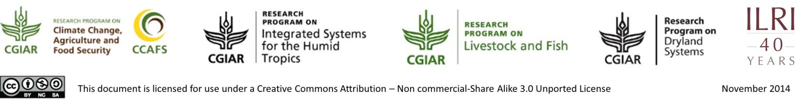

A rapid, quantitative assessment of household level food security: description of the data collection tool and the analysis

M.T. van Wijk¹, R. Ritzema¹, D. Valbuena², S. Douxchamps¹ and R. Frelat^{1,3}
¹ ILRI, International Livestock Research Institute
² CIAT, International Center for Tropical Agriculture
³ CIMMYT, International Maize and Wheat Improvement Center

Based on data availability assessments of a wide range of different surveys from different agricultural development-oriented efforts in sub Saharan Africa, we have developed a simple food security indicator that can be quantified on the basis of these surveys. The indicator quantifies the ratio between food availability and household level food needs, and also quantifies the (relative) importance of different agricultural and off-farm activities for this indicator. Using the data needs for this analysis as a basis, we then developed a so-called mini-survey that collects the quantitative, yearly, information needed to perform these calculations, and that is available together with this document.
Figure 1 displays the key components of the analysis. A simple Food Security Ratio (FSR) is defined to be the ratio of total physical energy available to a household via crop and livestock production as well as food that can be purchased (‘food available’; MJ-year⁻¹), to the physical energy requirements of the household (‘food need’; MJ-year⁻¹). Households
with FSR values less than 1 are thus considered food-insecure.
Food crop products
Cash crops products
Livestock products
Off farm income
Food available
Food need
Buy staple crop
Household size and composition
Consumed
Consumed
Sold
Sold
Food Security Ratio
Expenses
Cash available
Livelihood Sources

Figure 1. Simple household Food Security Ratio calculation

To estimate household ‘food need’, members of the household are disaggregated by gender and age classes, following FAO/WHO methodology. Energy requirements for each gender and age class are multiplied by the number of household members in each category and summed to produce the food need of the household.
An example of the results that can be obtained in the analysis is given in Figure 2. These are results obtained for Lushoto, Tanzania, one of the CCAFS benchmark sites (www.ccafs.cgiar.org), in which 200 farm households were interviewed. The results show a large variation in food security ratio values, accompanied by a strong shift in farm orientation: where the food insecure farmers concentrate in their on farm activities on consumption of produced food crops, roughly food secure farmers are selling their food crops as well, while the food secure farm households are market oriented: they produce cash crops and/or have cattle. Associated to these shifts in farm orientation also the potentially interesting interventions options differ between these groups.
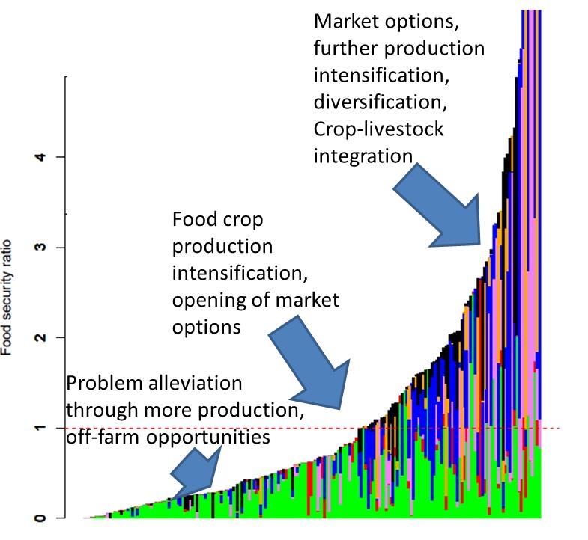
Figure 2. Food security analysis for the CCAFS benchmark site in Lushoto, Tanzania. Results of individual farm households are shown, ordered along the x-axis.

The food security calculations consider six primary livelihood components: crop and livestock products that are sold or consumed, and cash crop production and off-farm income that contribute to cash reserves. Annualized crop and livestock values are based on farmer-reported quantities produced, consumed, and sold. This information is collected in the two ‘mini’ surveys attached. Two versions of the survey are made available: one that also collects information on gender control over the benefits of on and off farm activities, and one that does not collect this info. The latter one is the most rapid, and therefore cheapest, option to perform the farm household level analyses shown here. Both surveys collect information on the household size and composition (form 2), farm and plot sizes (form 4), crop production, consumption and sales (form 5), livestock assets (form 7), livestock production, consumption and sales (form 8) and off farm income (form 9). For the gender survey also information on gender specific control over the benefits of these activities is collected in forms 5, 6, 8 and 9. The surveys are also available digitally on tablet, using the ODK software (http://opendatakit.org). At the moment (Dec. 2014) we are developing interfacing software to automatically link the ODK software output to the food security analysis tools in place in order to perform rapid data quality control and food security assessments.
It is clear from the description above that the data collection and analysis tools are not meant for in depth, farm specific analysis, but are meant to
- derive rapid and cheap food security and value of production assessments across populations of farm households;
- quantify the (relative) importance of different on and off farm activities;
- identify the key drivers of the observed differences in food security levels;
- form the basis for rapid intervention analyses; and
- form the core of more detailed surveys focusing on specific questions; by implementing this core mini-survey the user is assured that the rapid food security analysis can be performed, and that results of this analysis can be linked to the other type of information he/she wants to collect.
For more in-depth studies more detailed survey instruments are needed, but using this rapid analysis framework in a first assessment can help to target and focus more detailed follow up studies for specific groups of farmers, thereby increasing the efficiency of the overall study design.

Key reference
Ritzema et al., 2014. Application of a simple food security analysis across a diverse set of smallholder farming systems in East and West Africa. To be submitted to Agric. and Food Security.

